PARSHAT TOLDOT: ESAU HAD THE MEANS AND MOTIVE.

WHY DIDN’T HE KILL JACOB?
SABBATH TABLE OUTLINE
This outline corresponds to the video: Esau Had The Means And Motive. Why Didn’t He Kill Jacob?
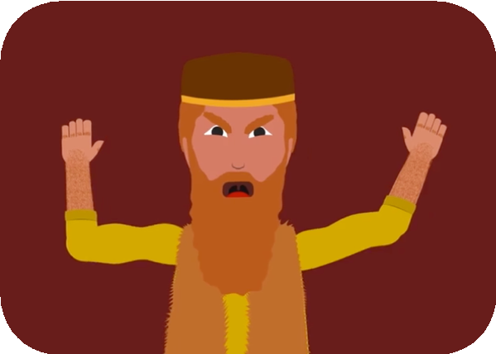
- Why didn’t Esav ever try to kill Jacob?
  - In Parshat Toldot, he swore that he was going to kill him. Jacob had just impersonated him and taken his blessing, and the Torah tells us, “And Esav hated Jacob because of the blessing that his father gave him, and Esav said to himself...I
will kill my brother Jacob.”
  - So… how come he never tries to kill him?
Guide by Dr. Sarah Levy
    - Until recently, I had an answer to this question: an answer that I found
perfectly satisfying. Esav never tried to kill
Jacob... because Jacob ran away! Jacob was in hiding for all those years, in Charan, with his Uncle Lavan. They didn’t reunite until twenty years later; and by that time, Esav had cooled off. Who holds a grudge for twenty years??
    - But then I reread Parshat Toldot, and I realized that there’s a problem with that answer. Take a look at what the text tells us, when Jacob runs away: “And Esav saw that Isaac had blessed Jacob and sent him to Padan Aram.”
  - That’s right. Esav knew where Jacob was hiding the whole time, from the very start! Why didn’t Esav just follow Jacob to Padan Aram and exact revenge?
    - The pieces just don’t seem to add up.
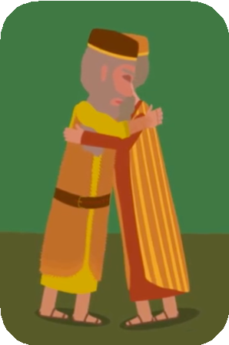
    - Esav swears he’s going to kill his brother; he’s got motive, he’s got opportunity… but he never follows through on it. It’s puzzling, don’t you think?

- Now, I grant you – several Midrashim do make the case that Esav may well have tried to murder Jacob.
  - One midrash suggests says that, immediately after the deception, Esav dispatched his son to kill his brother.
  - Another says that when he leaned in to kiss Jacob, twenty years later, he was actually trying to bite his neck.
  - But it is not so simple. Other Midrashim see Esav as acting with genuine compassion toward his brother. And still, getting back to
the text itself, the bottom line is: He doesn’t kill him, after he had vowed to. And at the end of the day, Esav is unnecessarily gracious. The question is: Why? What happened here?

- I want to suggest to you that the key to understanding Esav’s puzzling behavior can be found in a few short verses at the very end of Parshat Toldot: the verses that describe what
happened after Jacob stole Esav’s blessing. There are some intriguing questions that emerge from those verses, and if we can deal with those questions, then we may be able to uncover a hidden story here
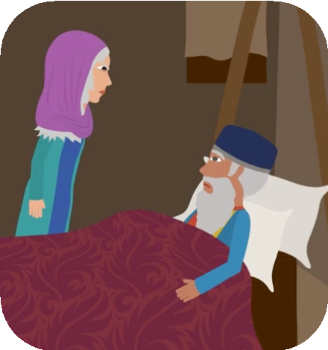
  - So let’s look at the verses. Esav has been deceived. He is furious, he swears he’s gonna to kill Jacob. Rebecca calls Jacob over and says: “Look, things could get violent. You’ve got to leave — right now. Go to Uncle Lavan’s house and stay
there until Esav cools down.”
  - But then it gets confusing. Rebecca turns to Isaac and says something that seems completely out of left field: “I am disgusted with my life because of the Hittite women who live around here. If Jacob were to marry a woman like this, one of these Canaanite women, I couldn’t bear it.”
  - What?? What is this? This is so random! Why is Rebecca suddenly so concerned about intermarriage? It’s such a weird thing to say.

- So that’s one question. And if you look at the very next verse, you’ll find a second question.
  - Isaac calls Jacob over — and remember, this is the very first conversation that they’ve had since Jacob deceived him, lied to him: “Isaac calls him in, he
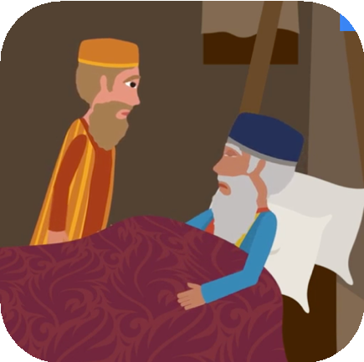
blesses him. He says: ‘Don’t marry a Canaanite woman. Go to Padan Aram, to Uncle Lavan’s house. Find a wife there.’”
  - And he doesn’t just bless him, he lavishes him with blessing: “May God bless you, make you fruitful and multiply you. May He give you the blessing of Abraham…”
  - It’s completely bizarre. Why isn’t Isaac angrier at Jacob? Why is he so quick to forgive and forget?
    - A clue might lie in that point we made eariler about Rebecca’s expressed concern, to her husband, about Jacob marrying Hittite women.
    - You see, where else in the Torah did we hear about marrying Hittite women?
    - Before all this, we are told that Esav married Hittite women. Yes, two verses hiding at the end of Chapter 26, just before the deception, fill in the details.
  - How do you think Isaac and Rebecca felt about their firstborn, the heir apparent, marrying these Canaanite women? We don’t have to speculate; just look at the next verse: “and they were a bitterness of spirit to Isaac and to Rebecca.”
    - Rebecca and Isaac have been displeased with Esav ever since he brought those Hittite daughters-in-law home.
    - But at the time, either Esav didn’t notice their displeasure, or he didn’t care.

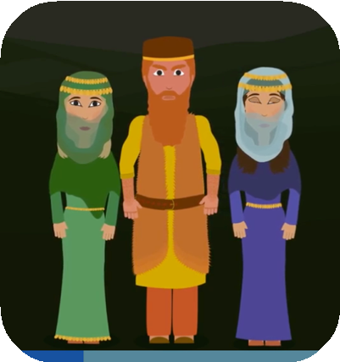
- It wouldn’t be the first time Esav just ‘didn’t care’, as it were. There’s another famous Esav story, where he expresses similar disregard towards things that might have been treasured in the family.
  - Years before, he had flippantly sold his bechorah, his firstborn status — whatever that means.
    - He sold it to Jacob for a bowl of soup! And the Torah itself makes an unusual value judgement about that.
    - When it comes to family, legacy, firstbornness, a pattern seems to be emerging: Esav just doesn’t seem to care.
  - But then something changes. All of a sudden, in the aftermath of the deception, Esav sees something, something that perhaps makes him start to care.
    - He sees his father call Jacob in for a little talk. Put yourself in Esav’s shoes – this is the moment you expect Jacob is going to get it. Ha! That scoundrel of a brother, that sneaky thief. He stole my blessing — Now Dad is gonna tell him off. Esav, presumably, sits back to watch.
    - But then, something shocking happens. Isaac isn’t angry. Far from it: he gives Jacob all of these blessings: the blessings of Abraham. If you’re Esav, you’re thinking: whaaat? How is this fair? It’s a double whammy - first Jacob steals my blessing, and then, Dad is validating what he did?
  - And now Esav had to have asked himself - why? Why are my parents, Isaac and Rebecca okay embracing Jacob as the new firstborn, the heir to Avraham? Why are they okay letting me go?
    - And then, perhaps, he starts to see: Maybe I haven’t been a model firstborn. I treated the whole birthright thing pretty dismissively, even scornfully. And then my Canaanite wives — that wasn’t what Dad wanted for the heir to Abraham. I was supposed to marry someone from the family, like he did. I disappointed him. Now Jacob swoops in, takes my blessing… I feel deceived, victimized, angry… but, my parents… maybe they think it’s for the best. The new firstborn Jacob is going to do it right: gonna marry the right girl, gonna follow his parents’ wishes. I had my chance, and I threw it away. I’m not the favored son anymore.
    - That maybe is what the verse means when it says: “And Esav saw that Isaac blessed Jacob, and that he sent him to Padan Aram.”
  - Why, of all places, to Padan Aram? Not just to run away: “to take a wife, he commanded him not to marry a local woman...”
  - Esav is watching this, and it hits him: “And he sees, he realizes - finally! - that his father was unhappy with the Canaanite women, with his wives...”
- All this seeing - it’s really understanding. Esav hears his father’s implicit rebuke, and finally he sees, maybe, the pain that he’s caused, and what that has cost him.
  - Do you remember the question we asked: Why didn’t Esav ever try to kill Jacob? Well, now, perhaps, we have our answer.
  - It’s because, in this moment, all of a sudden, Esav’s anger at Jacob takes a backseat, it gives way to a stronger emotion. Esav seems to be thirsting for his father’s love and approval.
  - The old Esav never thought much about Dad’s approval: Not when he was selling off his birthright for lentils, not when he was marrying those Hittite women.

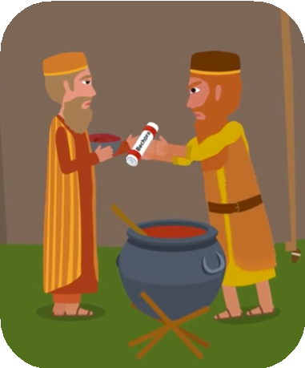
  - But now, Dad’s approval has been taken out from under him and it’s left him reeling, rejected, distraught.
- So, in the end, he doesn’t seek revenge. He doesn’t try to kill Jacob — not here and not 20 years later in Parshat Vayishlach — even though he knows exactly where his brother is hiding.
  - What does he do? Where does he go?
  - Look at the very next verse: “Esav goes to Uncle Ishmael” -- why?
  - He finds himself a third wife. Who is this Machalat? She’s a grandchild of Avraham!
  - Esav is finally expressing sensitivity to his parents’ pain.
  - He’s marrying someone from the family, someone he can bring home, who will make Mom and Dad proud. He can never get the
blessing of Abraham, that’s gone forever — but maybe, just maybe, he can win back his parents’ approval.
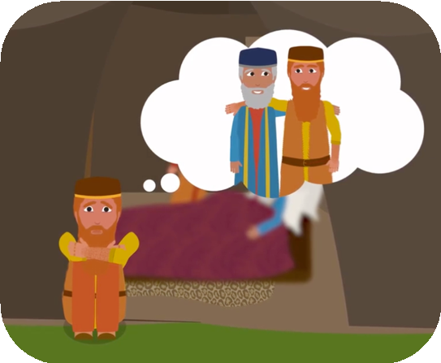
- Esav isn’t just the confident, cavalier, self-sufficient man of the field that we met at the start of Parshat Toldot. In the aftermath of the deception story, we see a side of him that is much more vulnerable than that, hurting, wanting nothing more than to
be accepted by his father. It is a different Esav, indeed.
  - It’s peculiar, the Sages of the Midrash often have harsh words to say about Esav. He’s sometimes even deemed Esav HaRasha, Esav the Wicked One. But if he is wicked… isn’t it interesting how, in the aftermath of the deception story, the Torah seems to go out of its way to help the reader feel some empathy for the situation he has found himself in?
    - How the Torah helps us understand something about how Esav develops, evolves, as a human being?
    - To feel compassion for someone manifestly imperfect… maybe that is part of the point of the story, here. Indeed, maybe it’s not just about honing our compassion for the rashas, the wicked people, in our midst.
    - Maybe it’s also about having compassion for ourselves. In those moments when we’re not our best selves — when we have a heated argument with someone that we love, when we say things that we don’t mean — and we’re looking back on it, be it later that day or even years down the line… do we sometimes look at ourselves as if we’re the rasha?
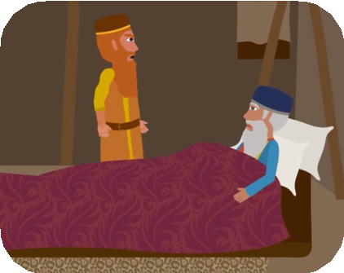
    - Do we become our own worst enemy? In those dark moments, it is worth remembering: compassion for the wicked starts at home.
- Thanks for watching. Some of you might have noticed that at the very start of this video, I quoted a verse… but I conveniently skipped over a few words.
  - So maybe Esav didn’t try to kill Jacob because he was waiting for their father Isaac to die! Easy - problem solved.
  - Do you think this throws a wrench in my theory? I don’t think
it does. I didn’t have enough time in this video to get into it, so — thank God Aleph Beta has a blog! Take a look at my blog post - link in the description of this video.

Hi, I'm Beth Lesch. Welcome to Aleph Beta, this is Parshat Toldot!

Let me ask you a question: Why didn’t Esav ever try to kill Jacob?

Why Did Esau
Forgive

Jacob
After Stealing the Blessings?

After all, in Parshat Toldot, he swore that he was going to kill him. Jacob had just impersonated him and taken his blessing, and the Torah tells us:

וַי ִ ּשְׂטֹם עֵשָׂו, אֶת י ַעֲקֹב, Jacob hated Esav And
;עַל הַבְּרכָה, אֲשֶׁר בֵּרכו אָבִיו

Because of the blessing that his father gave him

וַ ֹיאמֶר עֵשָׂו בְּלִבּו,

And Esav said to himself

אַהַרג ָה, אֶת י ַעֲקֹב אָחִי....

...I will kill my brother Jacob.

So… how come he never tries to kill him?

Questions
About
the

Story of
Esau and

Jacob

Until recently, I had an answer to this question: an answer that I found perfectly satisfying. Esav never tried to kill Jacob... because Jacob ran away! Jacob was in hiding for all those years, in Charan, with his Uncle Lavan.

They didn’t reunite until 20 years later; and by that time, Esav had cooled off. Who holds a grudge for 20 years??

But then I reread Parshat Toldot, and I realized that there’s a problem with that answer. Take a look at what the text tells us when Jacob runs away:

ַפדנ ָה אֲרם
י ִצְחָק אֶת י ַעֲקֹב, וְשִׁלַּח אֹתו
וַי ַ ּ ְרא עֵשָׂו, כִּי בֵר

And Esav saw that Isaac had blessed Jacob and sent him to Padan Aram.

That’s right. Esav knew where Jacob was hiding the whole time, from the very start! Why didn’t Esav just follow Jacob to Padan Aram and exact revenge?

The pieces just don’t seem to add up. Esav swears he’s going to kill his brother; he’s got motive, he’s got opportunity… but he never follows through on it. It’s puzzling, don’t you think?

Did Esau Try to
Kill

Jacob?

Now, I grant you – several Midrashim do make the case that Esav may well have tried to murder Jacob. One midrash suggests says that, immediately after the deception, Esav dispatched his son to kill his brother. Another says that when he leaned in to kiss Jacob, 20 years later, he was actually trying to bite his neck.

But it is not so simple. Other Midrashim see Esav as acting with genuine compassion toward his brother. And still, getting back to the text itself, the bottom line is: He doesn’t kill him, after he had vowed to.
And at the end of the day, Esav is unnecessarily gracious. The question is: Why? What happened here?
I want to suggest to you that the key to understanding Esav’s puzzling behavior can be found in a few short verses at the very end of Parshat Toldot: the verses that describe what happened after Jacob stole Esav’s blessing. There are some intriguing questions that emerge from those verses, and if we can deal with those questions, then we may be able to uncover a hidden story here.

A Closer
Study of

Jacob
and Esau's

Story
in the Bible

So let’s look at the verses. Esav has been deceived. He is furious, he swears he’s gonna to kill Jacob. Rebecca calls Jacob over and says: “Look, things could get violent. You’ve got to leave – right now. Go to Uncle Lavan’s house and stay there until Esav cools down.”

But then it gets confusing. Rebecca turns to Isaac and says something that seems completely out of left field:

קַצְתִּי בְחַי ַ ּי, מִפְנ ֵי בְּנות חֵת. אִם לֹקֵחַ י ַעֲקֹב אִשָׁה מִבְּנות חֵת כָּאֵלֶּה, מִבְּנות הָאָרץ לָמָּה לִּי, חַי ִ ּים.

I am disgusted with my life because of the Hittite women who live around here. If Jacob were to marry a woman like this, one of these Canaanite women, I couldn’t bear it.

What?? What is this? This is so random! Why is Rebecca suddenly so concerned about intermarriage? It’s such a weird thing to say. So that’s one question.

And if you look at the very next verse, you’ll find a second question. Isaac calls Jacob over – and remember, this is the very first conversation that they’ve had since Jacob deceived him, lied to him.

וַי ִ ּקרא י ִצְחָק אֶל י ַעֲקֹב

in, him calls Isaac וַי ְברךְ אֹתו
he blesses him

וַי ְצַוֵ ּהו ּוַ ֹיאמֶר לו לֹא תִקַּח אִשָׁה מִבְּנות כְּנ ָעַן

He says: ‘Don’t marry a Canaanite woman. Go to Padan Aram, to Uncle Lavan’s house. Find a wife there.

And he doesn’t just bless him, he lavishes him with blessing:

אֹתְךָ, וְי ַפרךָ וְי ַ ְרבֶּךָ
ׁדי י ְבר
וְאֵל

you multiply and fruitful you make you, bless God may וְי ִתֶּן לְךָ אֶת בִּרכַּת אַבְרהָם
may He give you the blessing of Abraham…

It’s completely bizarre. Why isn’t Isaac angrier at Jacob? Why is he so quick to forgive and forget?

The Differences Between Esau and Jacob

A clue might lie in that point we made eariler about Rebecca’s expressed concern, to her husband, about Jacob marrying Hittite women.

You see, where else in the Torah did we hear about marrying Hittite women? Before all this, we are told that Esav married Hittite women. Yes, two verses hiding at the end of Chapter 26, just before the deception, fill in the details:

וַי ְהִי עֵשָׂו, בֶּן אַרבָּעִים שָׁנ ָה old, years 40 was Esav When
וַי ִ ּקַּח אִשָׁה אֶת י ְהו ּ ִדית, בַּת בְּאֵרי הַחִתִּי

Hittite, the Be’eyri of daughter the Yehudit married he וְאֶת בָּשְׂמַת, בַּת אֵילֹן הַחִתִּי

and Basmat the daughter of Eilon the Hittite.

How do you think Isaac and Rebecca felt about their firstborn, the heir apparent, marrying these Canaanite women? We don’t have to speculate; just look at the next verse:

וַתִּהְי ֶין ָ, מֹרת רו ּחַ, לְי ִצְחָק, ו ּלרבְקָה

and they were a bitterness of spirit to Isaac and to Rebecca.

Rebecca and Isaac have been displeased with Esav ever since he brought those Hittite daughters-in-law home. But at the time, either Esav didn’t notice their displeasure, or he didn’t care.

Who Was Esau?

It wouldn’t be the first time Esav just ‘didn’t care’, as it were. There’s another famous Esav story, where he expresses similar disregard towards things that might have been treasured in the family.

Years before, he had flippantly sold his bechorah, his firstborn status – whatever that means. He sold it to Jacob for a bowl of soup! And the Torah itself makes an unusual value judgment about that: The text says, הַבְּכֹרה אֶת עֵשָׂו ּבֶז ִ וַי– “Esav despised the birthright” – he belittled it.

When it comes to family, legacy, firstbornness, a pattern seems to be emerging: Esav just doesn’t seem to care.

But then something changes. All of a sudden, in the aftermath of the deception, Esav sees something, something that perhaps makes him start to care. He sees his father call Jacob in for a little talk.

Sibling Rivalry Between Esau and Jacob

Put yourself in Esav’s shoes – this is the moment you expect Jacob is going to get it. Ha! That scoundrel of a brother, that sneaky thief. He stole my blessing – now Dad is gonna tell him off. Esav, presumably, sits back to watch.

But then, something shocking happens. Isaac isn’t angry. Far from it: he gives Jacob all of these blessings: the blessings of Abraham.

If you’re Esav, you’re thinking: whaaat? How is this fair? It’s a double whammy – first Jacob steals my blessing, and then, Dad is validating what he did?

And now Esav had to have asked himself – why? Why are my parents Isaac and Rebecca okay, embracing Jacob as the new firstborn, the heir to Avraham? Why are they okay letting me go?

And then, perhaps, he starts to see: Maybe I haven’t been a model firstborn.

What Esau Learns After
Jacob

Takes Their Father's Blessings

I treated the whole birthright thing pretty dismissively, even scornfully. And then my Canaanite wives, that wasn’t what Dad wanted for the heir to Abraham. I was supposed to marry someone from the family, like he did. I disappointed him. Now Jacob swoops in, takes my blessing… I feel deceived, victimized, angry… but, my parents… maybe they think it’s for the best. The new firstborn Jacob is going to do it right: gonna marry the right girl, gonna follow his parents’ wishes. I had my chance, and I threw it away. I’m not the favored son anymore.

That maybe is what the verse means when it says:

,וַי ַ ּ ְרא עֵשָׂו כִּי בֵר י ִצְחָק אֶת י ַעֲקֹב

And Esav saw that Isaac blessed Jacob,

וְשִׁלַּח אֹתו ַפדנ ָה אֲרם

and that he sent him to Padan Aram.

away: run to just Not Aram? Padan to places, all of Why, לָקַחַת לו מִשָׁם אִשָׁה
to take a wife,

לֹא תִקַּח אִשָׁה מִבְּנות כְּנ ָעַן...

he commanded him not to marry a local woman...” Esav is watching this, and it hits him:
וַי ַ ּ ְרא עֵשָׂו, כִּי רעות בְּנות כְּנ ָעַן, בְּעֵינ ֵי, י ִצְחָק אָבִיו

And he sees, he realizes – finally! – that his father was unhappy with the Canaanite women, with his wives...”

All this seeing – it’s really understanding. Esav hears his father’s implicit rebuke, and finally he sees, maybe, the pain that he’s caused, and what that has cost him.

The
Moral

Lesson
Behind Esau and

Jacob's
Story

Do you remember the question we asked: Why didn’t Esav ever try to kill Jacob? Well, now, perhaps, we have our answer.

It’s because, in this moment, all of a sudden, Esav’s anger at Jacob takes a backseat, it gives way to a stronger emotion. Esav seems to be thirsting for his father’s love and approval.

The old Esav never thought much about Dad’s approval: Not when he was selling off his birthright for lentils, not when he was marrying those Hittite women. But now, Dad’s approval has been taken out from under him and it’s left him reeling, rejected, distraught.

So, in the end, he doesn’t seek revenge. He doesn’t try to kill Jacob – not here and not 20 years later in Parshat Vayishlach – even though he knows exactly where his brother is hiding. What does he do?
Where does he go?

Look at the very next verse:
וַי ֵ ּלֶךְ עֵשָׂו, אֶל י ִשְׁמָעֵאל
why? – Ishmael Uncle to goes Esav לו לְאִשָׁה …וַי ִ ּקַּח אֶת מָחֲלַת בַּת י ִשְׁמָעֵאל Machalat. daughter, his marries he and
He finds himself a third wife. Who is this Machalat? She’s a grandchild of Avraham! Esav is finally expressing sensitivity to his parents’ pain.

He’s marrying someone from the family, someone he can bring home, who will make Mom and Dad proud. He can never get the blessing of Abraham, that’s gone forever – but maybe, just maybe, he can win back his parents’ approval.

Esav isn’t just the confident, cavalier, self-sufficient man of the field that we met at the start of Parshat Toldot. In the aftermath of the deception story, we see a side of him that is much more vulnerable than that, hurting, wanting nothing more than to be accepted by his father. It is a different Esav, indeed.

Finding Spiritual Meaning in Esau and
Jacob's

Story

It’s peculiar, the Sages of the Midrash often have harsh words to say about Esav. He’s sometimes even deemed Esav HaRasha, Esav the Wicked One.

But if he is wicked… isn’t it interesting how, in the aftermath of the deception story, the Torah seems to go out of its way to help the reader feel some empathy for the situation he has found himself in? How the Torah helps us understand something about how Esav develops, evolves, as a human being?

To feel compassion for someone manifestly imperfect… maybe that is part of the point of the story, here. Indeed, maybe it’s not just about honing our compassion for the rashas, the wicked people, in our midst.

Maybe it’s also about having compassion for ourselves.

In those moments when we’re not our best selves – when we have a heated argument with someone that we love, when we say things that we don’t mean – and we’re looking back on it, be it later that day or even years down the line… do we sometimes look at ourselves as if we’re the rasha? Do we become our own worst enemy?

In those dark moments, it is worth remembering: compassion for the wicked starts at home.

Thanks for watching. Some of you might have noticed that at the very start of this video, I quoted a verse… but I conveniently skipped over a few words. Here’s the full verse, in all its unabridged glory:

,וַי ִ ּשְׂטֹם עֵשָׂו, אֶת י ַעֲקֹב

And Esav hated Jacob

;עַל הַבְּרכָה, אֲשֶׁר בֵּרכו אָבִיו

Because of the blessing that his father gave him

וַ ֹיאמֶר עֵשָׂו בְּלִבּו, himself to said he And
י ִקרבו ּי ְמֵי אֵבֶל אָבִי, וְאַהַרג ָה, אֶת י ַעֲקֹב אָחִי.

Let the days of mourning for my father draw near, and I will kill my brother Jacob.

So maybe Esav didn’t try to kill Jacob because he was waiting for their father Isaac to die! Easy – problem solved.

Do you think this throws a wrench in my theory? I don’t think it does. I didn’t have enough time in this video to get into it, so thank God Aleph Beta has a blog! Take a look at my blog post – link in the description of this video.

THE PARSHA EXPERIMENT
PARSHAT TOLDOT: ALL’S WELL THAT ENDS WELL
This guide corresponds to the video: Toldot: Isaac and the Wells – What's That About?
SABBATH TABLE OUTLINE

- The book of Genesis is full of stories of Abraham and Jacob
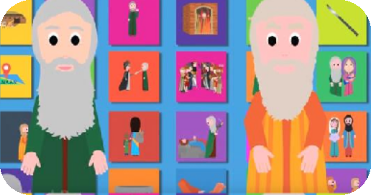
  - We know a lot about them
  - We know much less about Isaac, the two stories associated with him aren't really focused on him
    - The Binding of Isaac is about Abraham
    - The story of the switched blessings, the story most discussed this week, is really focused on Jacob and Esau
Guide by Dr. Sarah Levy
  - Who was Isaac, and what do we know about him?
    - There is only one story in the Torah that features Isaac as the main character
    - Because of the blessings, it's often glossed over

- 20 second parsha recap
  - After years of being unable to conceive, Rebecca gives birth to twins
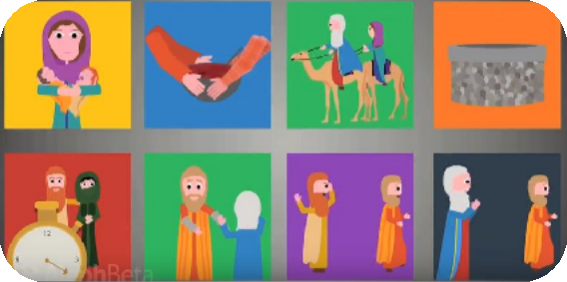
  - Esau sells his birthright to Jacob for stew
  - There is a famine, and Isaac goes to Gerar
  - He settles, and tries to dig a bunch of wells
  - Esau marries
  - Isaac wants to bless Esau, and Jacob pretends to be Esau and tricks his father
  - Jacob runs away because Esau vows to kill him
  - Before he does, Jacob makes a promise to marry a woman from Canaan
    - Did you spot the Isaac story?

- The one story that focuses on Isaac is the story of the wells, and understanding it may give the key to unlocking the mystery of who Isaac is
  - Here is what happened:
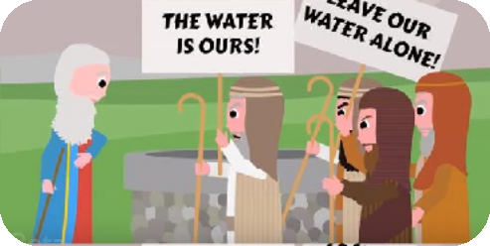
    - After the famine, Isaac settles in Gerar, and something amazing happens
    - Isaac plants in the land, and it grew, and he became great; the people became jealous, and he was asked to leave (Genesis 26:12-14)
    - He moves to the valley
    - Then is the strange story of the wells

- Apparently, Abraham had dug a few well during his time
- Since Abraham died, the locals plugged up the wells
- Isaac tries to dig the wells
- He dug the first, but the local shepherds fought with him about it, saying it was theirs; he named the well "contention" (Genesis 26:20)
- Isaac digs another well, but the locals try to claim that one too; Isaac calls that one "hatred" (Genesis 26:21)
- He moved away from there and dug a third well, and no one fought him for it; he named the well "expansion" (Genesis 26:22)

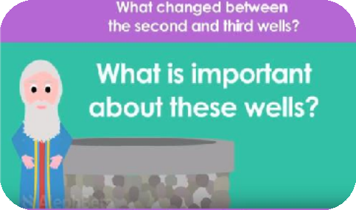
- There are a lot of questions to be asked; focus on two:
  - What happened between the second and third wells?
    - The locals argued over the first and second wells, but they just stop by the third - why?
    - Did they just give up? What changed?
  - Why is this the story God chooses to tell about Isaac?
  - Explore together the character of Isaac and strange story of the wells

- The story of the wells actually begins a few verses earlier in a prophecy
  - Before Isaac landed in Gerar, he was actually on his way to Egypt to get food
  - God appears and says not to go down to Egypt, reiterating the covenant (Genesis 26:3)
  - Isaac settles in Gerar (Genesis 26:6)
  - It seems like Isaac did exactly what God told him to do, but that's not exactly true
    - Looking carefully at what God told Isaac and what he actually did, God told him to גור, and he ישב (temporarily versus permanently)
    - A few weeks ago when discussing God's selection of Abraham, spoke of the challenges that come along with wealth
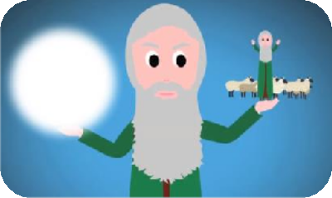
      - If God is going to make your name great so that you can bring blessing to the world, how do you balance being a prince of God with the pride and arrogance of being handed that destiny?
      - God told Abraham that he will get the land, but not quite yet
      - Verse careful to say that when Abraham returns to the land with so much wealth, there were others in the land (Genesis 13:6-7)
      - Why do we have to know that?
      - Abraham was wealthy with great gifts from God to be used to positively impact others
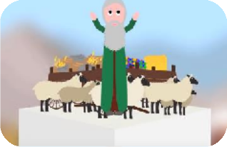
      - When you're put on a pedestal, can have the opposite effect
      - Could rub others the wrong way
      - Abraham saw that, so he didn’t settle, show off his wealth; pitches tents
    - Isaac, who would continue Abraham's mission, is faced with a similar situation
      - When God appeared to Isaac in Gerar, He promised to give him land
      - The gifts of land/wealth are tools for his mission to influence others
      - Something went wrong
        - Isaac settled down and became really wealthy
        - His wealth and great name weren't making a positive influence; they were having the opposite effect
        - The people around him were jealous, and he was asked to leave

  - Now the wells make so much more sense
    - In Jewish law, one way to show ownership of land is changing something
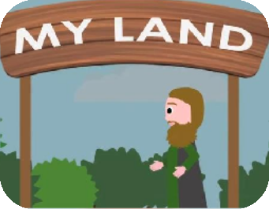
      - Only an owner has freedom to do what he wants It's almost like the wells were a symbolic claim of ownership
    - Isaac digs wells to say, "It's my land," but he wasn't successful in claiming the land - The locals challenged him, saying it's their water
    - Then something changed, something so subtle it could be easily missed
      - Isaac doesn't just dig a third well; he does something first
      - He removed himself from there (Genesis 26:22)
        - Who cares that he removed himself?
        - Does that remind you of anything?
    - There's only one other time that the word ויעתק appears
      - Right after the first time God promises land and children to Abraham, text says that Abraham removed himself from there (Genesis 12:8)
      - Might think that's just a coincidence, but looking at the situations of Abraham’s story and Isaac's story, they seem to be identical
  - Right after God promises the land to his children, Abraham responded not by planting roots, but by traveling and removing himself
    - He realized that the land isn't his yet
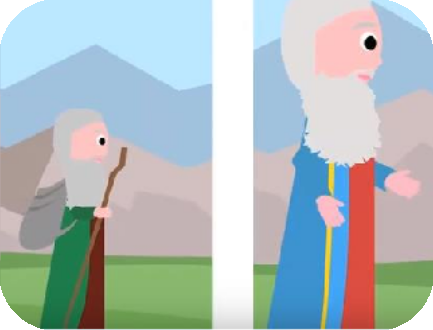
    - He hears the promise
    - Maybe, by using the same word in this parsha, the text is saying the Isaac got that message also
      - He no longer tries to plant roots; he moves away
      - He doesn't fight them for the land
  - That's what changed between the second and third well
    - By removing himself from the land, he showed that the third well isn't about marking territory
    - As soon as Isaac shows God that he understands that, there is no more struggling over that last well
  - Isaac calls the third well "expansion" because God expanded the land (Genesis 26:22)
    - He showed God that he could not lose sight of the gift giver and the purpose
    - Then, God is ready to fulfill His promises

- As the text continues, the seemingly-boring details all highlight Isaac's shift in perspective
  - What is the next thing Isaac does?
    - He goes from there to Be'er Sheba (Genesis 26:23-24)
    - Who cares? Why is the verse telling us this travel log?
    - Evan after Isaac gets to Rehoboth, the place of expansion, he voluntarily moves again because Isaac has shifted his perspective
    - He no longer claims land; he sojourns
  - Then God appears to him in another prophecy
    - Difference between this prophecy and the first prophecy from earlier
    - God says not to fear, He is with him and will bless him (Genesis 26:23-24)
    - God mentions the promise of children, but land is entirely missing
      - It's almost like God is speaking in negative space - what God doesn't say
      - Isaac is able to see that the land is a tool to accomplish his mission

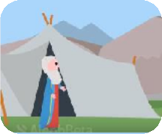
      - When that happens, it's like God gave him the land already
      - Isaac showed God that he uses the tools of land and wealth sensitively
      - So God doesn't need to mention it
      - By leaving it out, perhaps God is telling Isaac that he earned the land

- Further connection to Abraham
  - Look at what Isaac does right after the prophecy - he builds an altar (Genesis 26:23-25) - Who else builds an altar after a prophecy? Abraham (Genesis 12:8)
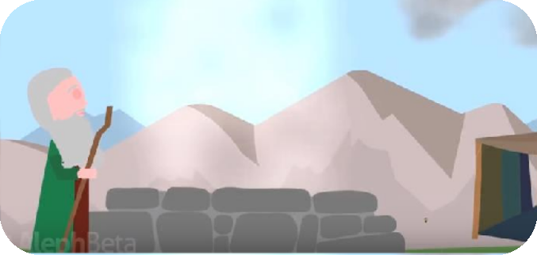
  - Both then call out in the name of God - Calling out in God's name right after God promises that he'll make your name
great is the ultimate way of showing that you won't become conceited, focusing only on yourself
  - After Isaac builds that altar, he pitches a tent (Genesis 26:25)
    - A tent is the best expression of temporary dwelling
    - Abraham build a tent right before building his altar (Genesis 12:8)

- Parallels not coincidental - text begged to connect the narratives
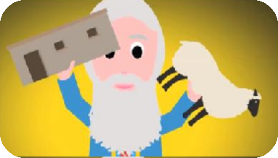
  - After being kicked out and opposed for the wells, Isaac realized what his father realized
  - It’s inappropriate to flaunt status as chosen people
    - Wealth is a powerful tool that should be used conservatively to fulfill a Godly mission
    - After Abraham passes away, the focus shifts to the next generation
      - Abraham had a divine mission, and now Abraham's child, Isaac, continues that legacy of becoming a model nation
      - God will bestow wealth, greatness, children upon this new nation
        - The promise of greatness and chosenness are hard to handle
        - God needed people who would be able to use these gifts properly as tools for spreading God's name and righteousness
      - After struggling a bit in Gerar, Isaac showed God that he's up to the task
        - Like his father, he will use his gifts with sensitivity
        - This story about overcoming a difficult challenge of being able to step out of one's own success and remember the larger picture is the story that the Torah chooses to tell
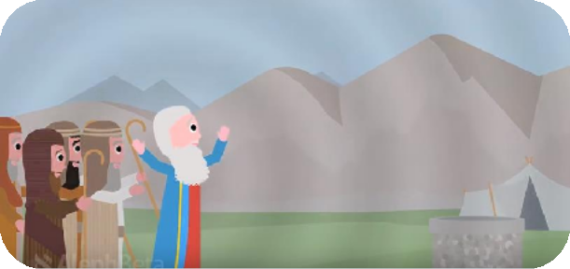

David: Welcome to Parshat Toldot.

The book of Genesis is full of stories about Abraham and epic tales about Jacob. We know a lot about them. But it seems that we know much less about Isaac.

Where Are the Bible's
Stories

About
Isaac?

In fact, the two stories that we normally associate with Isaac aren't really focused on Isaac.

The Binding of Isaac is primarily about Abraham, and the story of the switched blessings – the story that's most often talked about this week – is really focused on Jacob and Esav. So, who was Isaac? And what are supposed to know about him?

Immanuel: There's only one story in the Torah that features Isaac as the main character. It actually takes up a nice amount of air-time in our parsha, but because of the excitement of the blessings story, it's pretty easy to just gloss over.

Before we get there, let's take a look at our 20-second parsha recap:
After years of being unable to conceive, Rebecca gives birth to twins. Esav sells his birthright to Jacob for some stew.
There's a famine and Isaac goes to Gerar.
He settles there and tries to dig a bunch of wells. Esav marries.
Isaac wants to bless Esav, and then Jacob pretends to be Esav, and tricks his father.
Jacob runs away because Esav vows to kill him… but before he does, Isaac makes him promise he won't marry a woman from Canaan.
David: Did you spot the Isaac story? The one story that focuses on Isaac is the story of the wells, and understanding it may give us the key to unlocking the mystery of who Isaac is.

Who Was Isaac in the Bible?

Immanuel: Here's what happened: After getting food during the famine, Isaac settles in Gerar – and something amazing happens. הַהִוא בָּאָרץ ִצְחָק י ַרע ְ ּז ִ וַי– Isaac planted in that land,

100-fold… produced land the and –וַי ִ ּמְצָא בַּשָׁנ ָה הַהִוא מֵאָה שְׁעָרים him. blessed
had God and –וַי ְברכֵהו י ְהוָה

וְג ָ ֵדל, עַד כִּי ג ָ ַדל מְאֹד ;וַי ִ ּג ְ ַדל הָאִישׁ thrive: to continued he And
he and great, became He –וַי ֵ ּלֶךְ הָלו

many had he and –וַי ְהִי לו מִקְנ ֵה צֹאן ו ּמִקְנ ֵה בָקָר greater! even became he until more and more grew
flocks of sheep and herds of cattle, רבָּה וַעֲבֻדה– and a great household.

But that didn't sit well with locals:
פְלִשְׁתִּים
ּאֹתו ְאו ְקַנ וַי– the Philistines envied him. And because of that,

Abimelech, King of Gerar, asks Isaac to leave. So he moves to the valley… and then we get our strange story of the wells.

Isaac Redigs Abraham's Wells
David: Apparently, Abraham had dug a few wells during his time, and the text tells us that since Abraham died, the locals had plugged them up.

So, Isaac tries to redig those wells. He digs the first, but the local shepherds fought with him about it.
"Contention" well the named Isaac –וַי ִ ּקרא שֵׁם הַבְּאֵר עֵשֶׂק, כִּי הִתְעַשְׂקו ּעִמּו So theirs. was it said They

because they contended with him.

Isaac digs another well, but the locals try to claim that one too! "Sitnah," which seems to mean hatred.

it calls Isaac so –וַי ִ ּקרא שְׁמָהּ, שִׂטְנ ָה

well. third a dug and there from away moved he –וַי ַ ּעְתֵּק מִשָׁם, וַי ַ ּחפֹר בְּאֵר אַחֶרת Finally,

רבו ּעָלֶיהָ
וְלֹא– and it was uncontested! No one fought him for it! רחֹבות
named he andוַי ִ ּקרא שְׁמָהּ

this well "Rechovot," which means expansion. ּבָאָרץ ּפרינו ּו לָנו ְהוָה י הִרחִיב עַתָּה כִּי ֹיאמֶר וַ– because God has expanded the land for us so that we can be fruitful there. And that's the story.

Immanuel: There are a lot of questions we can ask, but let's focus on just two.

The first question is about the story itself. What happened between the second and third wells? The locals argued over the first well, argued over the second… and but then they just stopped by the third. Why? Did they just get lazy and give up? I mean, what changed??

And the second question is a more general one: Why is this the story God chooses to tell us about Isaac?? Who cares about these wells?

Exploring
Isaac's Character

Through
the Wells He Dug

David: Let's explore together the character of Isaac and this strange story of the wells, this week on the Parsha Experiment.

Immanuel: Hi, I'm Imu Shalev. David: And I'm David Block.
Immanuel: And well-come to the Parsha Experiment…. Get it? Wells??

David: Wow…

The
Story

Behind Isaac's Wells

Immanuel: The truth is the story of the wells actually begins a few verses earlier – in a prophecy. Before Isaac landed in Gerar, it seems that he was actually on his way down to Egypt to get food – and God appears to him. God says: Don't go down to Egypt! Stay here, in Gerar – הַזאת בָּאָרץ ּר ּו ג! And
you. bless and you with be I'll and –וְאֶהְי ֶה עִמְּךָ וַאֲבָרכֶךָּ
Then, God reiterates the covenant he made to Abraham: If you follow in my way, Isaac, I'll bless you with land and children. Great. So what happens next? ָרר ְ בִּג ,ִצְחָק י ּשֶׁב ֵ וַי– Isaac settles in Gerar. It seems like Isaac did exactly what God told him to do.

David: But that's not exactly true… look carefully again at what God told Isaac to do and at what he did. God said: הַזאת בָּאָרץ ּר ּו ג– sojourn, temporarily, in the land. Like a stopover. But Isaac did more than that: ִצְחָק י ּשֶׁב ֵ וַי– he settled. That implies permanence. He planted roots.

Immanuel: So here's our theory. A few weeks ago, when we discussed God's selection of Abraham, we spoke about the challenges that come along with promises of wealth and chosen-ness. If God is going to make your name great so that you can bring blessing to the world, how do you balance being a prince of God with the pride and arrogance at having been handed that destiny?

In Lecha Lecha, God told Abraham that he will get the land – but not quite yet. And the verse there is careful to tell us that when Abraham returned from Egypt with so much wealth that the land couldn't
וְהַכְּנ ַעֲנ ִי, וְהַפרז ִ ּי, אָז, יֹשֵׁב בָּאָרץ. Lot, nephew, his and him both support

There were others in the land. Why do we have to know that? Abraham was wealthy. He had these great gifts from God that were ultimately meant to be used in his role to positively impact others.

But when you have so much, when you're put on a pedestal, it can easily have the opposite effect. You can rub others the wrong way. You can use the tools insensitively. Abraham saw that potential… so he doesn't settle down. He doesn't show off his wealth. He sojourns. He pitches tents.

David: And now, Isaac, the one who could continue Abraham's mission, is faced with a similar situation. When God appeared to Isaac in Gerar, God promised that He'll give him the land. The gift of land and wealth, they're meant to be tools to help Isaac in his mission to be a positive influence on others.

But something went wrong. Isaac settled down, and he became really wealthy, but his wealth and his great name weren't making a positive influence. They were having the opposite effect.
.פלִשְׁתִּים ,ּאֹתו ְאו ְקַנ וַיIt made the people around him really jealous! So much so that Abimelech, king of
Gerar, had to ask him to leave!

Immanuel: Now the wells make so much more sense.

The
Symbolism of

Isaac's Wells in the Bible

Immanuel: In Jewish law, one of the ways in which one shows ownership of land is by changing

something in the land itself. Only an owner has the freedom to do what he wants with his land.

It's almost like the wells were a symbolic claim of ownership of land. Isaac digs wells to say. "It's my land!"

But he wasn't successful in claiming the land. The locals challenged him and said, "No, that's not yours – ִם ּהַמָּי לָנו– it's our water! It's always been ours!"

David: Then something changed. Something so subtle that you could easily miss it.

The Significance of Isaac's Third Well
David: Isaac doesn't just dig a third well. He does something first: אַחֶרת בְּאֵר ּחפֹר ַ וַי ,מִשָׁם ּעְתֵּק ַ וַי– he removed himself from there, and then he dug another well. Who cares that he removed himself from there??? But does that remind you of anything?

There's only one other time that the word – ויעתק– appears in all of the Five Books of Moses. Right after God promises land and children to Abraham for the first time, it says, הָהָרה מִשָׁם ּעְתֵּק ַ וַי– Abraham removed himself from there to a mountain.

Immanuel: You might say, "Who cares? That's a coincidence." story and Isaac's story – they seem to be identical too!
But look at the situations of Abraham's

Right after God promises the land to his children, Abraham responded not by settling the land and planting roots – as we discussed in Lech Lecha. Instead, he traveled. He sojourned. He removed himself. He realized that the land isn't his yet. He hears the promise, but he doesn't grab.

And it seems that, maybe, by using the same word in our parsha, the text is telling us that Isaac got that message too. He no longer tries to plant roots. He moves away. He doesn't grab and fight them for that land. And that's what changed between the second the third well. .מִשָׁם ּעְתֵּק ַ וַיBy removing himself from the land, He showed that the third well wasn't about marking his territory anymore.

David: And as soon as Isaac shows God that he realizes that, that he has corrected his ,ּשֶׁב ֵ וַיhis permanent
settling, there's no more struggling over that third well. And look at what he says. ,רחֹבות ,שְׁמָהּ ּקרא ִ וַי–
because –וַ ֹיאמֶר כִּי עַתָּה הִרחִיב י ְהוָה לָנו ּ, ו ּפרינו ּבָאָרץ expansion! "Rechovot," well third the calls he here. fruitful be can I that so land the expanded has God NOW

It happened right then. When he showed God that he can have the gifts and not lose sight of their giver and of their purpose, then God is ready to fulfill His promises to him.

Immanuel: And as you continue reading, the seemingly boring details that follow all seem to be there in order to highlight this shift in Isaac's perspective.

What's the next thing Isaac does? שָׁבַע בְּאֵר ,מִשָׁם ּעַל ַ וַי– he goes from there to Be'er Sheva. Who cares?
Why is the verse telling us this travel log? But that's exactly the point… even after Isaac gets to Rechovot to the place of expansion, he voluntarily moves again. Because Isaac learned his lesson and shifted his perspective. He no longer claims land and settles down. He sojourns.

Isaac Receives
God's

Promise

David: And then God appears to him in another prophecy. See if you can spot the difference between this prophecy and the first prophecy to Isaac that we read earlier. ,אָנֹכִי אִתְּךָ כִּי ,תִּירא אַל– do not fear,
your make and you bless I'll –ו ּברכְתִּיךָ וְהִרבֵּיתִי אֶת ז ַ ְרעֲךָ, בַּעֲבו ּר אַבְרהָם עַבְדי you. with am I for
children great for my servant, Abraham. Did you spot the difference?

God mentions the promise of children… but land is entirely missing! It's almost like God's speaking here in negative space – in what God doesn't say. Isaac is able to recognize that the land is a tool to accomplish his mission, and when that happens, in a sense, it's like God gave him the land already.

Isaac already showed God that he can use the tool of land and wealth sensitively. So God doesn't need to mention it – and by leaving it out, perhaps, God is symbolically saying, Isaac you already earned it. You already got the point.

Immanuel: And if the " "ויעתקconnection to Abraham from above wasn't compelling enough, look at
what Isaac does right after this prophecy. ְבֵּח מִז שָׁם ּבֶן ִ וַי– he builds an altar. Who else builds an altar after
God promises him things? Abraham! After Abraham moved, as we saw, ְבֵּח מִז שָׁם ּבֶן ִ וַי– he built an altar.

And now back to Isaac: ְהוָה י בְּשֵׁם ּקרא ִ וַי– and he calls out in the name of God! We've seen that before, too. Abraham builds his altar, and then ְהוָה י בְּשֵׁם ּקרא ִ וַי– he calls out in the name of God.

We explained in Lech Lecha that calling out in God's name right after God promises that he'll make you great is the ultimate way of showing that you won't become conceited and focus only on yourself… it's not just about me, it all comes from God.

David: And it continues. After Isaac builds the altar and calls out in the name of God, אָהֳלו ,שָׁם ּט ֶ וַי– he
pitches his tent. A tent is the best expression of temporary dwelling. He doesn't build a permanent house. He pitches a tent. And look what Abraham did, right before he built his altar: אָהֳלֹה ּט ֵ וַי– he pitched his tent.

The Spiritual Meaning Behind Isaac's and Abraham's Wells
Immanuel: These parallels aren't coincidental. The text is begging us to recognize what's going on here.
Isaac began by settling permanently, by taking the land. וישבinstead of .גורBut after he was kicked out
of Gerar, after he couldn't hold onto his second well in a row, he realized something… he realized what Abraham, his father, realized too.

This is just our take on the parallels, but it seems like the text is telling us that it is inappropriate to flaunt our status as chosen people. Wealth is a powerful tool, but it should be used conservatively, to fulfill a Godly mission.

David: After Abraham passed away at the end of last week's parsha, the focus automatically shifts to the next generation. Abraham had a divine mission, and now Abraham's child, Isaac, has to continue that legacy of becoming a model nation.

God will bestow wealth, greatness, land and children to this new nation. And as we said, the promise of greatness and the prospect of chosen-ness are very hard to handle. God needed people who would be able to use these gifts properly – as tools, in the mission of spreading God's name and teaching righteousness and justice to the world.

After struggling for a bit in Gerar, Isaac showed God that he's up to the task. Like his father, he'll use his gifts with sensitivity – that's how you impact others.

And this story – one of overcoming the difficult challenge of being able to step out of one's own success and remember the larger picture – that's the story the Torah chooses to tell us about Isaac.

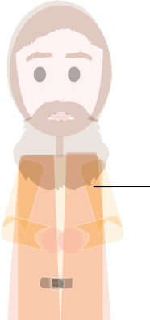

TOLDOT: A CONVERSATION FOR THE AGES
Welcome to the Aleph Beta Study Guide to Parshat Toldot!

No Ordinary Blessing
Many of us think we know the familiar story of Jacob stealing the blessing from his older brother Esau, which occurs in Parshat Toldot. But upon second and third glance, this story is way odder than it seems. We want to invite you to forget everything that you think you know about this tale - and understand what is truly happening in this story.

Let’s get into the scene: We’ve got an aging father (Isaac) whose eyesight is fading fast and who is preparing to die. He calls to Esau, his firstborn son, and says: “I’d like to give you a blessing, but first, if you wouldn’t mind, a tasty meat dish would really hit the spot right now.” Esau grabs his hunting implements and makes a beeline for the forest. Meanwhile, Isaac’s wife Rebecca overhears the conversation -- and leaps into action. She calls for Jacob, the younger son. On his mother’s command, Jacob dresses himself like Esau. In the end, he manages to dupe his elderly father, making off with the blessing which was intended for Esau. When Esau returns and finds out that his father blessed Jacob, he screams, begins to cry, and vows to kill his brother.

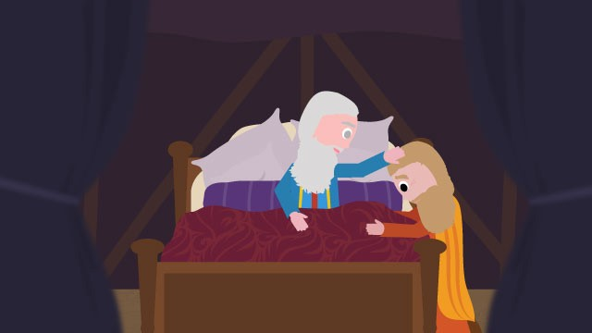
Which raises the question: Isn’t Esau being a little over- dramatic? It’s just a blessing. Blessings don’t seem to be a limited resource. The Torah tells us about many blessings given by a parent to a child. Noah blesses his sons Shem and Japheth after the flood. Jacob doles out blessings to all of his sons, including his grandsons Ephraim and Manasseh.
Each week at the Shabbos table, many parents bless each of their children using the text of Bircat Kohanim, the priestly
blessing. Imagine that one child cuts in front of the other. Sure, it’s not nice, but it doesn’t usually inspire a civil war. But this blessing in Parshat Toldot that Isaac wants to give to Esau --
it’s no Shabbos table blessing. It’s something quite unordinary. That much is clear from Rebecca’s reaction, from Esau’s reaction. The question is: What do they know that we don’t?

Let’s take a closer look at this conversation between Isaac and Esau and try to read between the lines.

INSTRUCTIONS

There are a lot of divrei Torah on the parsha. How is this different?
At Aleph Beta, we believe that the Torah is a guidebook that answers life’s biggest questions, offering profound insights about how we should live our lives. Moreover, we believe that Jewish tradition has always recognized the right of all readers, in every generation, to look at the text themselves and try to decide what they think it means. That means you. That’s why you are the most important author of this quest through the sources. We think that this guide offers a fun, stimulating and relevant path through the sources, but if you get wrapped up in a stimulating discussion and never make it past page 2, we’ll consider that a success!

Is this guide for self-study or should I study it with others?
Either works! You can gather a small group of friends to explore it together, share it with a chevruta (learning partner), or go through it by yourself.
Do I need to prepare anything or can I just jump in?

Just jump in! Even if you’re planning to use this for a group discussion, just open up to page 1 and get going. (If you read it in advance, it will spoil the fun!) The only thing you should do in advance is print out copies of the “Source Sheet” for the other participants, so everyone can follow along and engage with the sources.

About the Author

Most of the material within – although not the particular language contained in this guide - was first developed and taught by Rabbi David Fohrman, founder and CEO of Aleph Beta, and is presented in his video, “Parshat Toldot: A Conversation For the Ages” (available for viewing at www. alephbeta.org). This guide was written by Beth Lesch, edited by Rivky Stern, and arranged by Laura Schembre.

A Familiar Refrain

LOOK INSIDE: Dive Into the Verses

Read the verse below, the very beginning of this blessing-stealing account, and ask yourself: Where have we heard these words before?

Genesis 27:1
בראשית כז:א

1 And it came to pass, that when Isaac was old, and
ּכי-ז ֵקן ִי ְצ ָחק, ַו ִּת ְכ ֶהיןָ ֵעי ָניו ֵמ ְראֹת; ַו ִ ּי ְק ָרא
א ו ְי ִהי

his eyes were dim, so that he could not see, he called Esau his elder son, and said unto him: ‘My son’; and he said unto him: ‘Here am I.’
ַו ּיֹא ֶמר ֵא ָליו, ּב ִני,
ַו ּיֹא ֶמר ֵא ָליו ה ָּגדֹל,
ֹו ּבנ
את-ע ָ ׂשו
הִ ֵּנ ִני.

Hint: Where else in the Bible do we find a father and son, one calling out to the other with a single word which expresses their relationship (in this case, “b’ni” - “my son”) and the response is “hineni” (“Here I am”)?

It is oddly reminiscent of a verse that we find in the akeida, the story of the binding of Isaac:

Genesis 22:7
7 And Isaac spoke unto Abraham his father, and said:
בראשית כב:ז
ז ַו ּיֹא ֶמר ִי ְצ ָחק ֶאל-א ְב ָר ָהם ָא ִביו, ַו ּיֹא ֶמר אָ ִבי,

‘My father.’ And he said: ‘Here am I, my son.’ And he
ה ֵאׁש ְו ָה ֵע ִצים, ְו ַא ֵ ּיה
ה ֵּנה
ִני; ַו ּיֹא ֶמר, ב
ו ּיֹאמֶר, הִ ֶּנ ִּני

said: ‘Behold the fire and the wood; but where is the lamb for a burnt-offering?’
לעֹ ָלה.
ה ֶּ ׂשה,

Even the cast is similar: Isaac is featured in both stories - and in both, he’s the one who begins the conversation. But in the akeida, he’s talking to his father Abraham, calling out ִבי אָ (“my father”) - and in our parsha, he’s talking to his son
Esau, calling out ִני בּ (“my son”).

Is there some essential similarity between the story in our parsha and the akeida? We’ve found a couple of interesting connections - but not yet enough to prove that these stories are really linked.

Looking For More
LOOK INSIDE: Toldot and the Akeida

Below we’ve reproduced the next few verses of the story from Parshat Toldot alongside two of the central verses of the akeida. Can you find any more parallels between them?
Toldot
Akeida
Genesis 27:2-5
בראשית כז:ב–ה
Genesis 22:7–8
בראשית כב:ז–ח
ֶמר, ִה ֵּנה-נא ָז ַק ְנ ִּתי; לֹא ָי ַד ְע ִּתי, י ֹום מ ֹו ִתי. ב ַו ּיֹא
ג ְו ַע ָּתה ָ ׂשא-נא ֵכ ֶלי ָך, ֶּת ְל ְי ָך ְו ַקׁ ְש ֶּת ָך; ְו ֵצא,
ֶמר ִי ְצ ָחק ֶאל-א ְב ָר ָהם ָא ִביו, ַו ּיֹא ֶמר ָא ִבי, ז ַו ּיֹא
ִה ֶּנ ִּני ְב ִני; ַו ּיֹא ֶמר, ִה ֵּנה ָה ֵאׁש ְו ָה ֵע ִצים, ו ּיֹא ֶמר,
ה ָּ ׂש ֶדה, ְוצ ּו ָדה ִּלי, צידה (צ ִיד.) ד ַו ֲע ֵ ׂשה- ִלי
ו ַא ֵ ּיה ַה ֶּ ׂשה, ְלעֹ ָלה. ח ַו ּיֹא ֶמר, ַא ְב ָר ָהם, ֱאלֹקים ַ
ַּכ ֲאׁ ֶשר ָא ַה ְב ִּתי, ְו ָה ִבי ָאה ִּלי--ואֹ ֵכ ָלה: מ ְט ַע ִּמים
ָב ֶר ְכ ָך ַנ ְפׁ ִשי, ְּב ֶט ֶרם ָאמ ּות. ה ְורִ ְב ָקה ב ֲעב ּור ְּת
י ְר ֶאה- ּל ֹו ַה ֶּ ׂשה ְלעֹ ָלה, ְּב ִני; ַו ֵ ּי ְלכ ּוׁ ְש ֵני ֶהם, ַי ְח ָ ּדו. ַ
ׁשֹ ַמ ַעת-- ְב ַד ֵּבר ִי ְצ ָחק, ֶאל-ע ָ ׂשו ְּבנ ֹו; ַו ֵ ּי ֶל ְך ֵע ָ ׂשו
ה ָּ ׂש ֶדה, ָלצ ּוד ַצ ִיד ְל ָה ִביא.

2 And he said: ‘Behold now, I am old, I know not the day of my death. 3 Now therefore take, I pray thee, thy weapons, thy quiver and thy bow, and go out
to the field, and take me venison; 4 and make me savoury food, such as I love, and bring it to me, that I may eat; that my soul may bless thee before I die.’ 5 And Rebekah heard when Isaac spoke to Esau his son. And Esau went to the field to hunt for venison, and to bring it.
7 And Isaac spoke unto Abraham his father, and said: ‘My father.’ And he said: ‘Here am I, my son.’ And he said: ‘Behold the fire and the wood; but where is the lamb for a burnt-offering?’ 8 And Abraham said: ‘God will provide Himself the lamb for a burnt-offering, my son.’ And they went, both of them, together.

We’ll start by sharing one of the first parallels that we noticed. In the akeida, Isaac asks his father a question:

Genesis 22:7

לעֹ ָלה

ה ֶּ ׂשה

ו ַא ֵ ּיה

Where is the lamb for the offering?

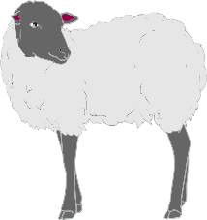
Isaac wonders why they didn’t bring a lamb along for the sacrifice. He’s thinking: ‘We need to get some meat.’ What about in our parsha? Sure, there’s no talk of sacrifice, no lamb. But we do find Isaac requesting of his son: “Please go out and hunt meat for me.” In both stories, Isaac is looking for animal. Interesting, no?

But maybe that’s still a bit of a stretch. After all, ׂשה ֶּ (“lamb”) and ִיד צָ (“game” or “venison”) are not the same thing. You’re probably thinking: “What else have you got?”

Well, let’s see if we can deepen this connection any more. When Isaac says to his father, “Where is the lamb for the offering?”, is that really all that he’s thinking? “We need to get meat”? Or is there more going on?
If you read our guide to Parshat Vayera, you realize that there’s a lot more meaning just beneath the surface of his question. Indeed, we think that there are at least two thoughts passing through Isaac’s mind as he asks this question. Here’s how I see it:
A

B
Isaac isn’t merely asking a logistical question. There they are, Abraham and Isaac, on their way to perform a sacrifice - but they don’t have any offering with them. That’s very odd. Didn’t Abraham plan ahead? Why doesn’t he seem bothered by the absence of the lamb? That all makes Isaac feel uneasy. He’s thinking: “Something fishy is happening.”
Once Isaac realizes that something fishy is going on, he begins to suspect what is really going on. He starts to think to himself: ‘I know what’s happening. I am the meat.’ It’s a moment of fearful realization:
“I might die today.”

PONDER THIS

Now turn back to the text quoted above from Parshat Toldot. Can you find anything that reminds you of these themes?

“Something fishy is happening.” “I might die today.”

Here’s what we found: take a look at verse 2, where we find Isaac speaking to his son Esau:

Genesis 27:2
ִה ֵּנה-נא ָז ַק ְנ ִּתי; לֹא ָי ַד ְע ִּתי, י ֹום מ ֹו ִתי

Behold now, I am old, I know not the day of my death

Isaac is essentially saying: “I’m getting old; I might die soon. It could be any day now. So I need you to do something for me.” It’s Element B: “I might die today.” Indeed, when was the last time that Isaac thought he was going to die? It’s an eerie echo of the akeida.

The Trail Goes Cold?
The father and son heart-to-heart, the hineni, all this talk of “meat” and of death - it really seems like we’re getting at least a partial replay of the akeida, right here in this conversation between Isaac and his son Esau. But what about Isaac’s notion that “Something fishy is happening?” which we find in the akeida? Is there an echo of that in Parshat Toldot?

There doesn’t seem to be any obvious echo - at least not in the verses that we’ve been examining. But then again, there’s more to Parshat Toldot than we’ve seen thus far. It’s true that in verse 5, the father-son conversation seems to end, with Esau making his exit and heading out to the forest with a bow and arrow. But if you skip down to verse 18, you’ll see that the father-son conversation picks up again, but with one crucial change - and this is where it gets truly fascinating. This time it’s Jacob who enters the room and strikes up a conversation with Isaac. He stands there before his blind father, pretending to be Esau. We know that this is a new conversation with a different son. But as far as Isaac is concerned, this is merely a continuation of his earlier conversation with Esau.

LOOK INSIDE: Looking for the “Something Fishy”

What exactly happens in this “Father-Son Conversation: Part II”? What does Jacob say to his father? Do you see anything odd going on here?

Genesis 27:18-20
בראשית כז:יח–כ

18 And he [Jacob] came unto his father, and said: ‘My
ה ֶּנ ִּני, ִמי
בא ֶאל-א ִביו, ַו ּיֹא ֶמר ָא ִבי; ַו ּיֹא ֶמר
יח ו ָ ּי

father’; and he said: ‘Here am I; who art thou, my son?’ 19 And Jacob said unto his father: ‘I am Esau thy first- born; I have done according as thou badest me. Arise,
אַ ָּתה ּב ִני. יט ו ּיֹא ֶמר ַי ֲעקֹב ֶאל-א ִביו, ָא ֹנ ִכי ֵע ָ ׂשו
ּב ֹכ ֶר ָך--ע ִ ׂשי ִתי, ּכ ֲאׁ ֶשר ִ ּד ַּב ְר ָּת ֵא ָלי; קום-נאׁ ְש ָבה, ו ָא ְכ ָלה ִמ ֵ ּצי ִדי-- ַב ֲעב ּור, ְּת ָב ְר ַכ ִּני ַנ ְפׁ ֶש ָך. כ ו ּיֹאמֶר

I pray thee, sit and eat of my venison, that thy soul may bless me.’ 20 And Isaac said unto his son: ‘How is it that thou hast found it so quickly, my son?’ And he said: ‘Because the Lord thy God sent me good speed.’
ִני; ַו ּיֹא ֶמר, ּב
ל ְמצֹא
י ְצ ָחק ֶאל- ְבנ ֹו, ַמה- ֶזה ִמ ַה ְר ָּת
ּכי ה ְק ָרה ְיקוה ֱאלֹ ֶהי ָך ל ָפ ָני.

Jacob presents his father with a platter of delicious meat, just as Isaac ordered. The thing is, Isaac’s request was to go out and hunt down some meat, but Jacob didn’t go hunting. He ran out to the backyard and grabbed two goats from the flock and brought them to her to cook. So even though Isaac can’t see, he picks up on the fact that something strange is happening. Listen to what he says:

Genesis 27:20

ּב ִני

ל ְמצֹא

מה- ֶזה ִמ ַה ְר ָּת

How did you find it so quickly, my son?

Isaac sure sounds suspicious. Indeed, he’s thinking: “Something fishy is going on!” That’s Element A! In the akeida, Isaac was suspicious about the meat - the sheep for the offering - and here again, Isaac is suspicious about the meat: “Gee, it’s odd that you were able to hunt so quickly. What’s going on here?” That’s yet another parallel between Toldot and the akeida.

And that’s not all. There’s something else going on here which invokes the akeida: a second replay of the hineni encounter! Did you see it in verse 18? Once again, we have a dialogue between a father and a son, with the expression of a single word which defines their relationship and the reply: hineni, “Here I am.” In fact, this exchange is an even closer match to the conversation at the akeida. In contrast to the hineni exchange between Isaac and Esau, here it’s the son (Jacob) who initiates, and the one word that he says is: ִבי אָ, “my father.” That’s precisely what we saw in the akeida.
LOOK INSIDE: Comparing Responses

The connections go still deeper. Take a look at the verses below. In the verse from our parsha, Jacob responds to Isaac’s “Something fishy is going on” question. And in the verse from the akeida, it is Abraham responding to Isaac’s “Something fishy is going on” question. What do these responses have in common?
Toldot: Jacob responds
Akeida: Abraham responds
Genesis 27:20
בראשית כז:כ
Genesis 22:8
בראשית כב:ח
ֶמר ִי ְצ ָחק ֶאל- ְבנ ֹו, ַמה- ֶזה ִמ ַה ְר ָּת ִל ְמצֹא כ ַו ּיֹא
ֶמר, ִּכי ִה ְק ָרה ְיקוה ֱאלֹ ֶהי ָך ְל ָפ ָני. ב ִני; ַו ּיֹא
ח ַו ּיֹא ֶמר, ַא ְב ָר ָהם, ֱאלֹקים ִי ְר ֶאה- ּל ֹו ַה ֶּ ׂשה ְלעֹ ָלה,
ב ִני; ַו ֵ ּי ְלכ ּוׁ ְש ֵני ֶהם, ַי ְח ָ ּדו. ְ
20 And Isaac said unto his son: ‘How is it that thou hast found it so quickly, my son?’ And he said:
‘Because the Lord thy God sent me good speed.’
8 And Abraham said: ‘God will provide Himself the lamb for a burnt-offering, my son.’ And they went,
both of them, together.

When Isaac suggests to his father in the akeida that something fishy is going on, how does Abraham respond? He says: “God will provide a lamb for Himself, my son.” Abraham evades Isaac’s question and evokes God as an answer.

Well, isn’t the same exact thing is happening in Parshat Toldot? When Isaac perceives his son standing there with the platter of cooked food and he suggests that something fishy is going on, how does Jacob respond? He says: “The Lord your God made it happen before me.” In other words, “God did it, God found it for me.” Jacob is evoking God as an answer, hiding behind God - just as his grandfather Abraham did.

All About Legacy
It really seems like these stories are connected in fascinating ways. Indeed, let’s pause and take inventory of the parallels thus far:

Akeida
Features Abraham and Isaac

Parshat Toldot - pt. I
Features Abraham and Isaac

Parshat Toldot - pt. II
Features Abraham and Isaac

Father and son Isaac is one of the characters
One person says: ִבי אָ (“my father”)
Father and son Isaac is one of the characters
One person says: ִני בּ
son”)

(“my
Father and son Isaac is one of the characters
One person says: ִבי אָ (“my son”)

Other person reponds ִני ֵּנ הִ Question which divides into three meanings:
Where’s the meat? Something fishy is going on
Am I going to die today? Responder hides behind God
Other person responds ִני ֵּנ הִ

Where’s the meat?

Am I going to die today?
Other person responds ִני ֵּנ הִ

Something fishy is going on

Responder hides behind God

PONDER THIS

What are we supposed to learn from all of these parallels between the akeida and Parshat Toldot? Why do you think they are there?

The parallels between these texts are pretty convincing. As for what it means, what the Bible is trying to tell us -- we can only speculate. But here’s how I see it: When you think about this conversation in Parshat Toldot in the context of the akeida, one thing starts to become clear. This blessing that Isaac wants to give over to his son Esau: it’s no ordinary blessing. This is a blessing about legacy.

Let us show you what we mean. Take a look at what happens at the end of the akeida:

Genesis 22:15-18
15 And the angel of the LORD called unto Abraham

בראשית כב:טו–יח
טו ַו ִ ּי ְק ָרא ַמ ְל ַא ְך ְיקוה, ֶאל-א ְב ָר ָהם,ׁ ֵש ִנית,

a second time out of heaven, 16 and said: ‘By Myself
ּכי,
ַּב ְע ִּתי ְנ ֻאם- ְיקוה: ּבי ִנׁ ְש
מִן- ַהׁ ָּשמָ ִים. טז ַו ּיֹא ֶמר,

have I sworn, saith the LORD, because thou hast
י ַען ֲאׁ ֶשר ָע ִ ׂשי ָת ֶאת-ה ָ ּד ָבר ה ֶ ּזה, ְולֹא ח ַ ׂש ְכ ָּת,

done this thing, and hast not withheld thy son, thine
את- ִב ְנ ָך ֶאת- ְי ִחי ֶד ָך. יז ּכי- ָברֵ ְך ֲא ָברֶ ְכ ָך, ְו ַהרְ ָּבה

only son, 17 that in blessing I will bless thee, and in
א ְר ֶּבה ֶאת-ז ְר ֲע ָך ּככ ֹו ְכ ֵבי הׁ ָּש ַמ ִים, ְו ַכחול, ֲאׁ ֶשר

multiplying I will multiply thy seed as the stars of the heaven, and as the sand which is upon the seashore;
ָּת ה ָ ּים; ְו ִי ַרׁש ַז ְר ֲע ָך, ֵאתׁ ַש ַער אֹ ְי ָביו. יח ב ַז ְר ֲע ָך, ֹכל ּג ֹו ֵיי ה ָא ֶרץ, ֵע ֶקב, ֲאׁ ֶשרׁ ָש ַמ ְע
על- ְש ַפת
ו ִה ְת ָּב ְרכ ּו

and thy seed shall possess the gate of his enemies; 18 and in thy seed shall all the nations of the earth be blessed; because thou hast hearkened to My voice.’
ִלי.
ְבּ

The climax of the akeida revolves around two things: blessing and offspring. In the akeida, God promises to give blessing to the world through Abraham. When Abraham is no longer alive, his offspring -- Isaac -- will become the bearer of that promise. Now, in Parshat Toldot, Isaac is getting old. The last link to Abraham is about to be lost. Who is going to pick it up? Isaac realizes that it’s time for him to pass down the blessing of Abraham. The question is, which offspring should become the new heir?

Isaac chooses Esau, and says to him: “It’s time for you to be the bearer of that blessing which was my destiny to bear. Now God will give blessing to the world through you.” That’s why his conversation with Esau is an echo of the akeida. That conversation is the vehicle for passing down the blessing from father to son. Isaac had that conversation with his father Abraham, and now he begins it anew with his son Esau.

PONDER THIS

If this theory is correct, then why does Jacob approach Isaac and say: ִבי אָ (“my father”)?

It really seems that the conversation between Abraham and Isaac at the akeida is being replayed in this encounter between Isaac and Esau… except there’s one big difference. In Parshat Toldot, the conversation is interrupted. It suggests that there’s some kind of major tension at play here. Isaac begins the conversation with his son Esau -- but he never finishes it.
Rebecca overhears the conversation between Isaac and Esau. Perhaps on some level she understands what is happening: that if Jacob is to inherit the blessing, he needs to interrupt the conversation between Isaac and Esau and enter into the conversation himself. And so Jacob approaches Isaac and says, ִבי אָ (“my father”). He too needs to re-enact the original conversation that took place at the akeida. It’s as if Jacob is saying: “I’m ready to inherit your legacy, Father, the one you inherited from your father. Let’s have that conversation.1
1 It’s worth noting that where Esau was passive -- merely responding to his father’s call -- Jacob shows initiative. He steps up and initiates the conversation, just like Isaac did so many years before in the akeida. It’s a show of passion, of readiness to carry on Abraham’s legacy. Maybe that’s the magic ingredient here, the crucial difference between Esau’s stalled conversation and Jacob’s success. One thing’s for sure: it’s with Jacob that the conversation finishes.

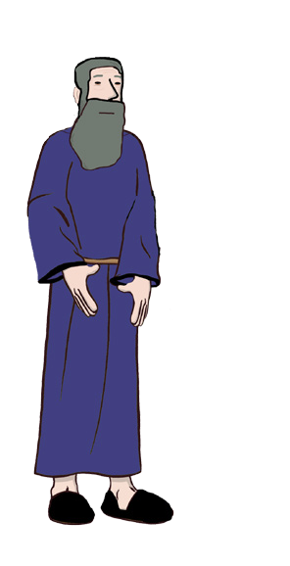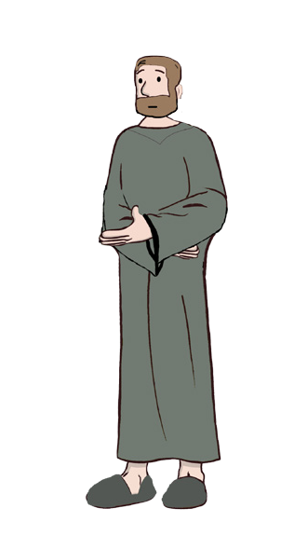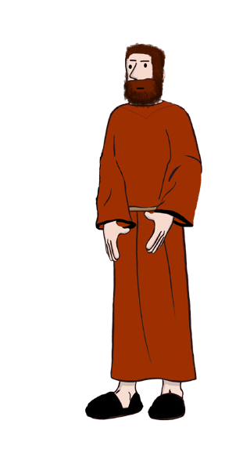Forgetting What you Know
Think of friends and family who will love it as much as you did - and share it with them!

And when you do, please remember to support Aleph Beta. Nothing makes us happier than bringing eye-opening, soul-heartening, life-changing Torah directly to you — but it all costs money. Like the cost of the writing, editing, design and circulation of the guide that you’re reading. So until we win the lottery, we need your support. Encourage your friends to subscribe to Aleph Beta, so they can get the guides sent directly to them! Or if you shared it with a friend and it was an awesome experience for both of you, consider making a small donation to show your love.

Thanks for understanding - we love you guys, too.
Love the guide?
Then SHARE and SUPPORT!
In a sense, because we’ve read the Bible before, because we’re familiar with how the story unfolds -- we’re blind to the drama of this moment. Yes, we know that Jacob becomes the new heir. We know that the avot, the forefathers of the Jewish people, are Abraham, Isaac and Jacob -- not Abraham, Isaac and Esau. We know that this was the moment in which Jacob was chosen, in which the baton was passed to him. But it wasn’t obvious then, and it didn’t have to be that way.
And, if we’re honest with ourselves, it’s not explicit in the text itself. Isaac doesn’t say: “Esau, I’m getting old, it’s time for me to select you as the chosen heir to Abraham’s legacy.” He simply says: “I want to bless you.” A blessing doesn’t have to be about legacy. There are plenty of ordinary blessings in the Torah. But this isn’t an ordinary blessing. So how do we know? What’s the proof that this is about the passing of the baton? It’s the parallels to the akeida that clue us in. That’s the key. That’s what the Bible is trying to tell us. You have to read between the lines to see it, but once you do, the connections are impossible to ignore. This is Esau’s moment to become one of the forefathers of the Jewish people. That’s why Esau was so devastated when it was stolen away from him.
In the akeida, we had a father and his son -- but here, in Parshat Toldot, there’s a father and two sons, Jacob and Esau. Only one son would bear the blessing of Abraham in the coming generation. The original conversation between father and son now splits in two. Isaac starts the conversation with Esau but he completes it with Jacob. In this moment, Jacob becomes the new bearer of God’s promise.
This is why, from here on out, the Torah tells the story of Bnei Yisrael, the children of Israel, and not the children of Esau. This is why God approaches Jacob’s children, and not Esau’s children, and offers them the Torah in exchange for their eternal service. It all happens here in this moment -- and the rest is history.

Toldot: A Conversation For the Ages
Source Sheet Page 1

Genesis 27:1
בראשית כז:א

1 And it came to pass, that when Isaac was old, and his
עי ָניו מ ְראֹת; ַו ִ ּי ְק ָרא
א ו ְי ִהי ּכי-ז ֵקן ִי ְצ ָחק, ַו ִּת ְכ ֶהיןָ

eyes were dim, so that he could not see, he called Esau
את-ע ָ ׂשו ּבנ ֹו ה ָּגדֹל, ַו ּיֹא ֶמר א ָליו ּב ִני, ַו ּיֹא ֶמר א ָליו,

his elder son, and said unto him: ‘My son’; and he said unto him: ‘Here am I.’ 2 And he said: ‘Behold now, I am old, I know not the day of my death. 3 Now therefore take, I
pray thee, thy weapons, thy quiver and thy bow, and go out
ָז ַק ְנ ִּתי; לֹא ָי ַד ְע ִּתי, י ֹום ה ֵּנה-נא
ׂשא-נא כ ֶלי ָך, ֶת ְל ְי ָך ְו ַקׁ ְש ֶּת ָך; ְו ֵצא, ִלי, צידה (צ ִיד.) ד ו ֲע ֵ ׂשה- ִלי מ ְט ַע ִּמים
הִ ֵּנ ִני. ב ו ּיֹא ֶמר,
מ ֹותִי. ג ו ַע ָּתה ה ָּ ׂש ֶדה, ְוצ ּו ָדה

to the field, and take me venison; 4 and make me savoury
ֶר ְכ ָך ְת ָב
ֲעב ּור ּב
ֵכ ָלה: ִלי--ואֹ
ְב ִּתי, ְו ָה ִבי ָאה א ַה
ּכ ֲאׁ ֶשר

food, such as I love, and bring it to me, that I may eat; that
ה ו ִר ְב ָקהׁשֹ ַמ ַעת-- ְב ַד ֵּבר אמ ּות.
נ ְפׁ ִשי, ּב ֶט ֶרם

my soul may bless thee before I die.’ 5 And Rebekah heard when Isaac spoke to Esau his son. And Esau went to the field to hunt for venison, and to bring it.
ּבנ ֹו; ַו ֵ ּי ֶל ְך ע ָ ׂשו ה ָּ ׂש ֶדה, לצ ּוד צ ִיד
י ְצ ָחק, אל-ע ָ ׂשו
ְלהָ ִביא.

Genesis 27:17–23

בראשית כז:יז–כג

17 And she gave the savoury food and the bread, which
ע ָ ׂש ָתה,
ַּמ ְט ַע ִּמים ְו ֶאת-ה ֶּל ֶחם, אׁ ֶשר את-ה
יז ַו ִּת ֵּתן

she had prepared, into the hand of her son Jacob. 18 And
א ִבי;
בא אל-א ִביו, ַו ּיֹא ֶמר
ּב ַיד, ַי ֲעקֹב ּב ָנ ּה. יח ַו ָ ּי

he came unto his father, and said: ‘My father’; and he said:
א ָּתה ּב ִני. יט ַו ּיֹא ֶמר ַי ֲעקֹב ה ֶּנ ִּני, מי
ו ּיֹא ֶמר

‘Here am I; who art thou, my son?’ 19 And Jacob said unto his father: ‘I am Esau thy first-born; I have done according as thou badest me. Arise, I pray thee, sit and eat of my venison, that thy soul may bless me.’ 20 And Isaac said unto his son: ‘How is it that thou hast found it so quickly, my son?’ And he said: ‘Because the LORD thy God sent me good speed.’ 21 And Isaac said unto Jacob: ‘Come near, I pray thee, that I may feel thee, my son, whether thou be my very son Esau or not.’ 22 And Jacob went near unto Isaac his father; and he felt him, and said: ‘The voice is the voice of Jacob, but the hands are the hands of Esau.’ 23 And he discerned him not, because his hands were hairy, as his brother Esau’s hands; so he blessed him.
אל-א ִביו, א ֹנ ִכי ע ָ ׂשו ּבכ ֶר ָך--ע ִ ׂשי ִתי, ּכ ֲאׁ ֶשר ִ ּד ַּב ְר ָּת
ָּת א ָלי; קום-נאׁ ְש ָבה, ְו ָא ְכ ָלה מ ֵ ּצי ִדי-- ַב ֲעב ּור, ְת ָב ְר ַכ ִּני ֶש ָך. כ ַו ּיֹא ֶמר ִי ְצ ָחק אל- ְבנ ֹו, מה- ֶזה מ ַה ְר נפְׁ
ּב ִני; ַו ּיֹא ֶמר, ּכי ה ְק ָרה ְיקוה אלֹ ֶהי ָך ל ָפ ָני. כא ל ְמצֹא
ִי ְצ ָחק אל- ַי ֲעקֹב, ְּגׁ ָשה- ָנא ַו ֲא ֻמׁ ְש ָך ּב ִני: ֶזה ּב ִני ע ָ ׂשו, אם-לֹא. כב ַו ִ ּי ַּגׁש ַי ֲעקֹב ו ּיֹא ֶמר ה ַא ָּתה
אל- ִי ְצ ָחק א ִביו, ַו ְי ֻמׁ ֵּשהו; ַו ּיֹא ֶמר, ה ּ ֹקל קול ַי ֲעקֹב, ו ַה ָ ּי ַדיִם, יְ ֵדי ע ָ ׂשו. כג ְולֹא ה ִּכיר ֹו-- ִכי-הי ּו ָי ָדיו ּכי ֵדי
ע ָ ׂשו א ִחיו, ׂש ִערֹת; ַו ְי ָב ְר ֵכהו.

Genesis 22:7–8

בראשית כב:ז–ח

7 And Isaac spoke unto Abraham his father, and said:
ִביו, ַו ּיֹא ֶמר א ִבי, א
ז ַו ּיֹא ֶמר ִי ְצ ָחק אל-א ְב ָר ָהם

‘My father.’ And he said: ‘Here am I, my son.’ And he said:
ב ִני; ַו ּיֹא ֶמר, ה ֵּנה ה ֵאׁש ְו ָה ֵע ִצים, ְו ַא ֵ ּיה
ֶּנ ִּני ה
ו ּיֹא ֶמר,

‘Behold the fire and the wood; but where is the lamb for
ח ַו ּיֹא ֶמר, א ְב ָר ָהם, אלֹקים ִי ְר ֶאה- ּל ֹו לעֹ ָלה.
ה ֶּ ׂשה,

a burnt-offering?’ 8 And Abraham said: ‘God will provide Himself the lamb for a burnt-offering, my son.’ And they went, both of them, together.
ּב ִני; ַו ֵ ּי ְלכ ּוׁ ְש ֵני ֶהם, ַי ְח ָ ּדו.
ָלה, לעֹ
ה ֶּ ׂשה

Toldot: A Conversation For the Ages
Source Sheet Page 2

Genesis 22:15-19

15 And the angel of the LORD called unto Abraham a second time out of heaven, 16 and said: ‘By Myself have I

ּכי,

אל-א ְב ָר ָהם,ׁ ֵש ִנית,
ִנׁ ְש ַּב ְע ִּתי ְנ ֻאם- ְיקוה: ּבי

בראשית כב:טו–יט

טו ַו ִ ּי ְק ָרא מ ְל ַא ְך ְיקוה,
מִן- ַהׁ ָּשמָ ִים. טז ַו ּיֹא ֶמר,

sworn, saith the LORD, because thou hast done this thing,
ה ֶ ּזה, ְולֹא ח ַ ׂש ְכ ָּת,
ע ִ ׂשי ָת את-ה ָ ּד ָבר
י ַען אׁ ֶשר

and hast not withheld thy son, thine only son, 17 that in
ֶד ָך. יז ּכי-ב ֵר ְך א ָב ֶר ְכ ָך, ְו ַה ְר ָּבה את- ְי ִחי
את- ִב ְנ ָך

blessing I will bless thee, and in multiplying I will multiply
ְר ֶּבה את-ז ְר ֲע ָך ּככ ֹו ְכ ֵבי הׁ ָּש ַמ ִים, ְו ַכחול, אׁ ֶשר א

thy seed as the stars of the heaven, and as the sand which is upon the seashore; and thy seed shall possess the gate of his enemies; 18 and in thy seed shall all the nations
ָּת ה ָ ּים; ְו ִי ַרׁש ַז ְר ֲע ָך, אתׁ ַש ַער אֹ ְי ָביו. יח ב ַז ְר ֲע ָך, ֹכל ג ֹו ֵיי ה ָא ֶרץ, ע ֶקב, אׁ ֶשרׁ ָש ַמ ְע

על- ְש ַפת
ו ִה ְת ָּב ְרכ ּו

of the earth be blessed; because thou hast hearkened to
א ְב ָר ָהם אל-נ ָע ָריו, ַו ָ ּי ֻקמ ּו ַו ֵ ּי ְלכ ּו ַי ְח ָ ּדו
בקֹ ִלי. יט ַו ָ ּיׁ ָשב

My voice.’ 19 So Abraham returned unto his young men, and they rose up and went together to Beer-sheba; and Abraham dwelt at Beer-sheba.
ָהם, ּב ְב ֵארׁ ָש ַבע. א ְב ָר
אל- ְב ֵארׁ ָש ַבע; ַו ֵ ּיׁ ֶשב

Hi everybody, this is Rabbi David Fohrman and welcome to Parshat Toldot.

In this week's parsha, we have the famous story of Yitzchak calling to Esav and seeking to bless him and, of course, instead Yaakov intervenes and Yitzchak blesses Yaakov instead. But I want to focus your attention on a very fascinating echo. What echo do we have in these words?

Biblical Parallels to
the

Story of
Isaac and Esau

"V'y'hi ki-zaken Yitzchak vatichena eynav me'rot" – Yitzchak was old. He could barely see –"vayikra et- Esav bno ha-gadol vayomer elav bni, vayomer elav hineini" – He calls to Esav, his oldest son, and says, "My son." Then Esav responds, "Hineini," – "Here I am."

Where have you heard these words before? Where else do we have a father and son, one calling out to another, with one word expressing their relationship and the response is "Hineini"? It's the story of the binding of Isaac. We talked about the conversation between Avraham and Yitzchak, going up the mountain. It's right there, in the conversation of the Akeidah, that we have the exact same setup.

"Vayomer Yitzchak el-Avraham aviv," and Yitzchak said to Avraham, his father, "Vayomer" – and he said, "Avi." Again, father and son. But this time it is son talking to father and the one word that is said, is "Avi," – "my father." What's Avraham's response? "Hineini bni." – "Here I am, my son."

So let's just set it up. Yitzchak to Avraham at the Akedah: "My father." Avraham: "Hineini" – Here I am. Now, Yitzchak to Esav in the next generation: "My son." Esav's response: "Here I am." Seems like it's pretty similar.

Let's continue comparing these two stories and see. In the Akedah, what happens after that initial exchange, after Yitzchak says, "My father," and Avraham answers, "Here I am my son"? Yitzchak has a question: "Vayomer hinei ha-esh v'ha-etzim v'ayeh ha-seh l'olah" – Here's the fire, here's the wood, Father, but where is the lamb for the offering? Now what did that question mean? You might say that the question sort of has three meanings: a superficial meaning, a little bit of a deeper meaning, and then a deeper meaning still.

The superficial meaning is: We were supposed to have meat for the offering but there's no meat. Where is the meat? But of course, there is a deeper meaning. As we've pointed out, Yitzchak's question isn't "Eifo ha-seh?" – Where exactly is the seh? The question is "Ayeh ha-seh l'olah?" And as I pointed out "ayeh" doesn't mean, "Where is it?" It means, "Where did it go?" How come there's no lamb for the offering here?

Yitzchak senses that something fishy is going on. It just doesn't add up. There's a fire, there's wood, but where's the lamb? He begins to intuit: something is going on. But then, of course, the deeper meaning still is what it is that Yitzchak intuits. What is he really saying with, "Where is the lamb?" He is worried, of course, that perhaps he is the lamb. Am I going to die now?

So again three levels of meaning.
Level A: Where is the meat for the offering? Level B: Something fishy is going on.
Level C: Am I going to die now?

Digging Deeper
into

Isaac and Esau's
Story

Now think of all of that and let's come back to the Yaakov and Esav story. What happens after Yitzchak calls to Esav, his son, and says, "My son," and Esav responds, "Hineini," – "Here I am"? So, the next words we have are, "Vayomer hinei-na zakanti; lo yadati yom muti." Yitzchak says, "Here I am. I am old. I don't know when I am going to die."

Isn't that fascinating? That was the third meaning of Yitzchak's own words in the Akedah story. Remember, by the way, that the Akedah story and the Yaakov and Esav story are linked by one other thing, which is that who is talking in both of these stories?

It's Yitzhak each time.

It's Yitzchak each time. Yitzchak to his father in the story of Akedah, Yitzchak now, to his son, Esav in the story of Yaakov and Esav.

But, right where we would expect it, right at the point where we are up to — Yitzchak's question to Avraham in the Akedah — we have a parallel to it in the next story with Yitzchak's request of his son Esav... and the request on some level is the same. I don't know whether I am going to die. I'd like you to do something. What do I want you to do?

"V'atah sa-na chelecha telyecha v'kashtecha." – "Go, get your implements together, your hunting implements," – "tze ha-sadeh," – "and go out to the field," – "v'tzudah li tzayid," – "and hunt for me food." What is he saying? "Where is the meat? There's no meat. Please bring me missing meat." Meaning C, meaning A, right after each other. It just seems like we are getting a replay of Yitzchak's dialogue with his father in this next story, Yitzchak's dialogue with his son.

From
Isaac to

Esau and
Jacob

Now here's the really fascinating thing. As you know, of course, Esav goes out to the fields and then Yaakov comes in and deceives his father, pretends that he is Esav and now listen to what happens, as Yaakov begins speaking, standing before his blind father. "Vayavo el-aviv," Yaakov came to his father, "vayomer," and he says, "Avi" – "My father." – "Vayomer hineini. Mi atah bni?" And Yitzchak says, "Here I am. Who are you my son?"

It's happening again. Son comes to father and says, "My father," just as in the Akedah. Yitzchak came to Avraham and said, "Avi," – "My father," and now Yaakov is coming to Yitzchak and saying, "Avi," –

"My father," and the answer is the same. Avraham said, "Hineini bni" – "Here I am, my son." Yitzchak now says to Yaakov: "Hineini. Mi atah bni?" – "Here I am. Who are you, my son?" It's all the same except for the insertion of the words, "Who are you?"

Now what happens next? Yaakov represents himself as Esav. "Anochi Esav bchorecha." – "I am Esav. I have done what you asked of me. Please eat the meat." "And now listen to what Yitzchak says. "Ma ze miharta limtzo bni." – "Gee, that was fast. How’d you find the meat so quickly?" What does that remind you of? Anything in the Akedah? That's what Yitzchak said to his father in the Akedah. It is the next thing that happened. That was meaning B: Gee there's something fishy going on. In the Akedah, the fishy thing was, where is the lamb for the offering?

In the next story, when Yitzchak blesses his sons, the fishy thing is, "Gee, how did you find it so fast?" Now let's listen to Yaakov's response, but as we listen to Yaakov's response, let's remember Avraham's response to the question of "Isn't something fishy going on?" posed to him by his son. Avraham, when asked by Yitzchak, "Where is the lamb for the offering?" said, "Elohim yireh-lo ha-seh l'olah bni." – "G- d will show for Himself a lamb for offering, comma, my son."

Avraham sort of evades Yitzchak's question, evokes G-d and says, "G-d is going to figure it out. G-d is going to find the lamb for the offering." And listen now to Yaakov's response to Yitzchak. Yitzchak says, "Gee, there's something fishy going on. How did you find the meat so fast?" "Vayomer ki hikra HaShem Eloheicha lefanai." – "G-d, your G-d, helped me find it quickly."

Yaakov, hiding behind G-d, just like Avraham before him had hid behind G-d. "G-d will help me find the meat for the offering, my son." It really seems like these stories are connected in fascinating ways. It's as if the conversation between Avraham and Yitzchak is being echoed in this next story, except there is one big difference.

Passing the Blessing: Abraham to
Isaac to

Esau to
Jacob

The conversation splits in the second story. You see in the first story, there was a father and one son, Avraham and Yitzchak, but here there's a father and two children, Yaakov and Esav. The original conversation between father and son now splits in two. What's the meaning of that? Why is part of the conversation between Avraham and Yitzchak now echoed in the conversation between Yitzchak and Esav, and the rest of the conversation echoed between Yitzchak and Yaakov. What does it mean?

So, I don't know. I can only speculate, but for what it's worth, let me throw out a possible idea. In the Akedah, Yitzchak became the bearer of a promise: Avraham's promise, the promise that G-d would give blessing to the world through Avraham: "Barech avarechecha." – "I will bring blessing to the world through you." And now at the end of Yitzchak's life, it's time for Yitzchak to pass down that blessing. He says, "I want my soul to bless you, my son, to let you be the bearer of that blessing which it was my destiny to bear."

He chooses Esav to be the bearer and he begins the conversation now, one more time. The conversation

which he remembers being the vehicle through which he received the mandate of Abraham. He will now have that conversation with his son, to be able to transfer that mandate to him. Yaakov, on some level, understands what's happening and knows that if he is going to get the blessing, he too, somehow, must enter into that conversation. It's as if he is saying to his father: You can have that conversation with me, too. Let's have that conversation. You began the conversation with Esav; complete it with me.

PARSHAT TOLDOT: WHAT IS ISAAC’S LEGACY?
This guide corresponds to the video: Toldot: The Child Of Isaac Is… Abraham??
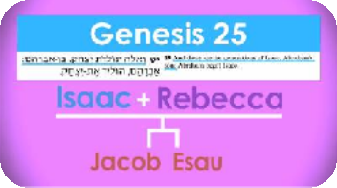
SABBATH TABLE OUTLINE

- Parsha begins in a strange way: "These are the generations of Isaac, the son of Abraham..." (Genesis 25:19)
  - After this, you'd expect to hear the legacy
  - Instead you hear about Isaac's father
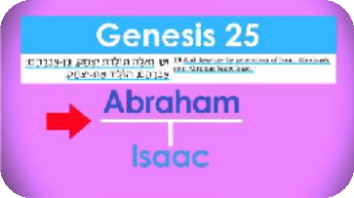
  - The issue of what "these are the generations…" means is an issue throughout Genesis
    - Many sections introduced with those words
    - What comes next is usually not what you'd expect
      - Beginning of Vayeishev: "These are the generations of Jacob..." but then launch into the story of Joseph, and the other tribes don't get mentioned at all
Guide by Dr. Sarah Levy
      - Does the Torah not understand what the words mean?

- Torah understands exactly what the words mean - the Torah is telling us about legacy
  - Bring it back to the first use of the phrase: "These are the toldot of heaven and earth as they were being created" (Genesis 2:4)
    - What a strange thing to say
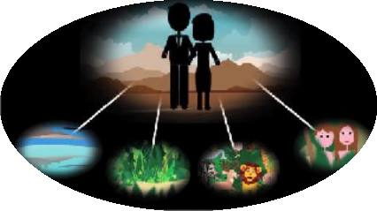
    - Heaven and earth are inanimate objects; what would they give birth to?
      - Heaven and earth do have a legacy
      - Everything that we are about to hear in this creation story will be told from the perspective of heaven and earth actually being parents
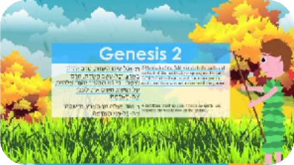
      - Everything comes from them
    - When did heaven and earth become fertile?
- Through rain!
- In the beginning, it was barren because there was not yet rain or man to cultivate the land (2:5)
- Mist rises up to seed the clouds, produces rain
- Heaven and earth are now fertile and can now produce
    - God creates man (2:7) from the earth
      - Now everything is the earth's project
      - Before man learns to cultivate the land, there is a first garden that God plants and cultivates

    - Four rivers are mentioned - why do we need this? (2:10-14)
      - It's the beginning of life
      - Water is the key element that is responsible for all life
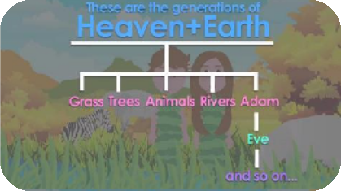
      - Torah is explaining how life springs from one place to cover the earth
    - God forms out of the ground all of the living creatures (2:19)
      - The ground and heavens had grandchildren (man was the first generation)
      - There is a legacy to heaven and earth - the rest of creation is their legacy
  - Next section about Noach: "These are the toldot of Noah" (Genesis 6:9)
    - Noach was a righteous man in his generation, walked with God
    - The next sentence talks about his kids, why doesn't the Torah start with that?
      - Torah is saying that the main thing Noah produced was Noah himself
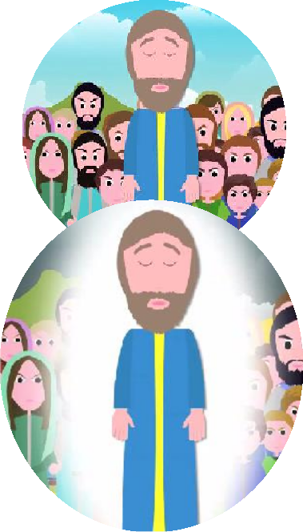
    - Noah produced himself because he was righteous
      - He went against the flow
      - He lived in a world that was passive follows evil - when he resisted that, he became a self-made man
    - Perhaps that gives us insight into why he was saved
      - The flood wasn't just about the destruction of people - it was about the earth and everything that heaven and earth had created together
    - "The world became corrupted before God...and filled with evil" (6:12)
      - The decree of destruction was against the world
      - Mankind was ancillary except for the one person who set himself apart as a self-made righteous man and (in that merit) survived
  - So what are toldot?
    - Can be biological generations, but usually more than that - legacy
    - What's your real legacy?

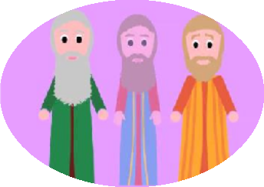
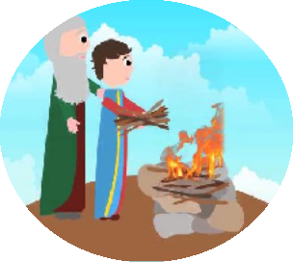
- Next “These are the generations…” - our section: "These are the generations of Isaac..."
  - Our version is the direct inverse of Noah's
  - What was Isaac's life about? What was his legacy?
    - Of all of the forefathers, we know the least about Isaac
    - The biggest thing is what happens to him - he is a passive object and lets something happen to him and is almost sacrificed
  - Who is this man?

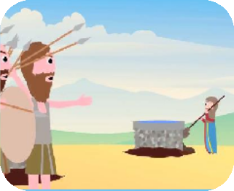
    - Seemingly trivial, often overlooked part of the parsha, story about wells
    - Isaac digs wells and has to rebuild them - that is the point!
  - What is the challenge of being the son of a great innovator?
- Business innovators build companies, but it is often destroyed when transitioning to the next generation
- George Washington was great, but if he wasn't followed by Adams, Jefferson and others, there would be no America - someone has to pick up the torch
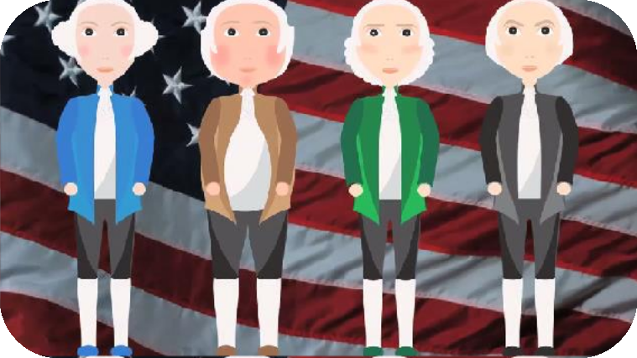

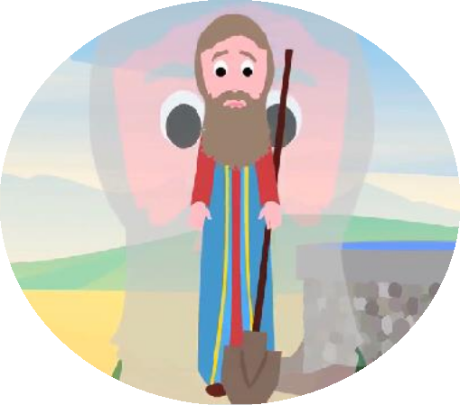
  - Isaac is about picking up the torch and consolidating father's legacy
    - He wants to keep father's vision alive for another generation
    - It's as if Isaac's greatest legacy is that he is the son of Abraham

- Sometimes your job in life is to innovate, and sometimes your job in life is to consolidate
  - Consolidating isn't as flashy and takes humility
  - That humility is heroic, and that is Isaac's legacy
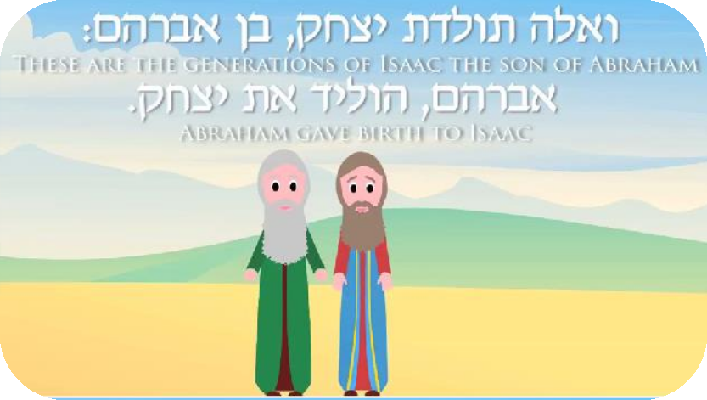

Hi everybody, this is Rabbi David Fohrman, and welcome to Parshat Toldot. You are watching Aleph Beta.

The
Story of

Isaac, the
Son

of Abraham

Our Parsha begins in a very strange way: " בֶּן־,֑ם ה
א ֛לֶּה תּֽולְדֹ֥ת י ִצח ֖ק אַבְר
וְThese are the generations of

Isaac, the son of Abraham." Now after that, you'd expect to hear about his legacy, his children, but you

don't.
֥יד י ִצח ֽק,אֶת־ ל
ה ֖ם הו
אַבְרAbraham gave birth to Yitzchak.

Those aren’t the generations of Yitzchak. That's not who Yitzchak gave birth to; that's Isaac's father. The
truth is, the issue of what תֹּֽלְד֣ות ֣לֶּה אmeans is a pervasive question throughout the Book of Genesis.
Because, throughout the book, there are all these sections that are introduced with those words. Almost invariably what comes next is not what you would expect. It's not “the generations of.”

שְׁבַע־בֶּן־ שָׁנ ָה " problem. same the have weוַיֵ ּ֣שֶׁב, of beginning the in Like
years seventeen was he when Yosef, Yaakov. of generations the are Theseא ֣לֶּה תֹּֽלְד֣ות יַ ֽעֲקֹ֗ב יוסֵ֞ף עֶשׂר ֤ה
old..." And then we launch into the story of Yosef. What happened to everybody else? The rest of the 12 Tribes don't get mentioned at all. It's like, does the Torah not understand what the words mean?

So, I want to suggest to you that the Torah understands exactly what the words mean, and the fact that every time we're supposed to hear a list of generations, we don't really get an accurate list... the Torah is telling you that the legacy of X is not what you might think at first glance. And to begin to get a sense of
how this might work, I want to bring you back to the very first of these תֹּֽלְד֣ות ֣לֶּה אsections.

Eleh Toldot...

֑ם " א
ב ֽ ְר
מ ֛י ִם וְהָא ֖ ֶרץ בְּה ֣
א ֣לֶּה תֽולְד֧ות הַשָׁ
These are the generations of heaven and earth as they were being

created." That's a strange thing to say. Heaven and earth are inanimate objects; What could they give birth to? It sounds just crazy. Well, maybe that's the whole point. Heaven and earth, as unimaginable as it might seem, do have a legacy. Everything you are about to hear in this creation story, is going to be told to you from the perspective of heaven and earth actually being parents; everything comes from them.

Think about it this way. If you think about heaven and earth as parents, when did heaven and earth become fertile, so to speak? Through rain. Listen to the very next words. In the beginning, it was barren.

ד֗ה טֶ֚רם יִ ֽהְיֶ ֣ה בָאָ֔רץ "
שׂ֣יח הַשָׂ
וְכֹ֣לThere was no vegetation in the land..." "... ֑ח ִצמ י ֶרם ֣ ט
ד֖ה
וְכָל־ הַשָׂ

becauseכִּי֩ לֹ֨א הִמְטִ֜יר י ְהֹוָ ֤ה אֱלֹהִים֙ הָאָ֔רץעַל־ "... Why? grown." yet not were grasses the all andע ֥שֶׂב

there was not yet rain," the beginning of fertility. " ֽהאֶת־ מ who could then cultivate things further."
ה ֽאד
ֽעֲבֹ֖ד ל
yet, man wasn't Thereוְאָד֣ם אַ֔י ִן

What's the Torah describing? A barren world where everything hadn't happened yet. What redeems that
barrenness? " ֶרץמִן־ ֑ הָא ֣ה ֽעל יַ ֖ד וְאMist rose up from the ground..."; the beginning of water arising from

the earth to seed the clouds. "... ֽה מ earth." The beginning of life.
ה ֽאד
פְנֵ ֥יכָּל־אֶת־
֖ה וְהִשׁקand rain came down to water the face of the

Heaven and earth are now fertile; they can now produce. And in that world, " ֣אדמָ֔המִן־ ה עָפָר֙ אֶת־
the just not was it because man create to able was He man." created Godוַ ֩י ִיצֶר י ְהֹוָ ֨ה אֱלֹהִ֜ים ה ֽאד֗ם
particles of dust; there was this clay, this newly fertile earth. God used that earth to make man.

Everything that happens now is going to be a function of what the earth's legacy is. The earth's progeny. God is going to cause to come out of the ground ֥ד ֶחמ נ ֛ץכָּל־ ֵע

There will be trees. Even before man learned how to cultivate vegetation with the agricultural
cultivated a planted Godוַי ִ ּטַּ֞ע י ְהֹוָ ֧ה אֱלֹה ֛ים בְּע ֖ ֶדןג ַּן־ " God. – gardener first a was there revolution,
garden for Himself, " establishing for man how it would be done.

And then the four rivers. Who cares about these four rivers? They bring water over here, and bring water over there to the four corners of the earth. Why do I need all of this? But it makes perfect sense. It's the beginning of bringing life to the world, in as much as water is the key element that is responsible for all life in a world in which heaven and earth are parents. The Torah is explaining to you how life spread out from one place to cover the entire globe; it was through the rivers.

And then, more progeny of heaven and earth. " שׂדה֙
ה ֽאדמָ֗המִן־ חַיַ ּ֤תכָּל־ הַ
Godוַ ֩י ִצֶר י ְהֹוָ ֨ה אֱלֹהִ֜ים

formed out of the ground all of the living creatures." And then the ground and heavens had grandchildren. Man as the first generation descendant. Woman taken from man, built out of his rib, becomes their grandchild, the second generation descendant. There is a legacy to heaven and earth; the rest of creation is their legacy.

Let's move on to the next תֹּֽלְד֣ות ֣לֶּה אsection of the Torah. The one that talks about Noach; also
puzzling. " ֔ח נֹ תּֽולְדֹ֣ת אֵ֚לֶּהThese are the generations of Noah." So I'd expect to hear about his kids, but
was He man. righteous a was Noachנֹ ֗ח א ֥ישׁ צַד ֛יק תָּמ ֥ים הָיָ ֖ה בְּדֹרֹת ֑יו " him. is about hear I thing first the
perfect in his generation." He walked with God. Why am I hearing about this? Tell me about his kids. That's what I get in the next sentence. Noach had three kids. Start with that. Maybe what the Torah is telling you is that the main thing that Noach produced was Noach himself.

" ֔ח נֹ תּֽולְדֹ֣ת אֵ֚לֶּהThese are the generations of Noach. Noach!" He produced himself. How?
֑יו בְּדֹרֹת ֖ה הָיָ ֛יק צַד ֥ישׁ אBecause "he is righteous." He went against the flow. When you live in a world
that's intensely evil, you live in a world in which basically everyone is passive and goes with the flow of the evil around them... until someone stands up for what's right, and when they do, they are the most self-made man you could imagine. And perhaps that gives us a bit of an insight into why he was saved.

מ ֛י ִם וְהָא ֖ ֶרץ, the Torah, the of sectionאֵ֚לֶּה תּֽולְדֹ֣ת last the that flood the in decree a was There
שָׁ
the

children of heaven and earth, they would all go. The flood was not just about the destruction of mankind. It was about the destruction of the earth, about everything that heaven and earth had created.

Listen to the words of the Torah, " ֑ים ה
ה ֽאֱלֹ
שׁח ֥ת הָא ֖ ֶרץ לִפְנֵ ֣י
וַתִּThe world became corrupted before

at looked Godוַ ַי ּ֧ ְרא אֱלֹה ֛ים הָא ֖ ֶרץאֶת־ " evil, with filled became world "The :וַתִּמָּל ֥א הָא ֖ ֶרץ חָמ ֽס God,"
earth," " ֑תָה ׁח ִ נ ּ֣ה וְהִנֵAnd, in fact, it was destroyed." The decree of destruction was against the world.
Mankind was ancillary. He was destroyed because there was nowhere else to live —except for the one person who set himself apart, who yes, biologically, was a child of heaven and earth like the rest of them, but was also the self-made righteous man and, in that merit, survived.

So what are toldot? Yes, they can be biological generations, but usually they are more than that. There is legacy. What's your real legacy?

The Legacy of Isaac's Family Tree

want Iוְא ֛לֶּה תּֽולְדֹ֥ת . י ִצח ֖ק parsha. our Torah, the of sectionאֵ֚לֶּה תּֽולְדֹ֣ת next the to come let's now And
to suggest that our תּֽולְדֹ֣ת אֵ֚לֶּהis a direct inverse of Noah's. “These are the generations of Yitzchak.”
What was Yitzchak's life about? What was his legacy? Among all the forefathers, the one we know the least about is Isaac. We know almost nothing about him. The biggest thing that happened to him, is what happens to him when he is an object, when he almost gets sacrificed on the altar, and he is passive; he just lets Abraham do with him what he will. Who is this man?

The clue lies in an oft overlooked part of our Parsha, seemingly trivial stories about wells. Isaac dug these wells. He dug that well. And the Philistines, they stopped up the wells of his father, Abraham, so Isaac kept on re-digging the wells, and they stopped them up some more, and so Isaac re-dug them again.
Why do we have to hear about all of that?All of that is the point.

What is the challenge of a child of a great innovator? Often, to carry the innovation to the next generation. Great businessmen who build companies — often it's destroyed when the transition to power happens in the next generation. Can the child hold it together?

You know, George Washington was great, but if George Washington wasn't followed by Adams, by Jefferson and Madison, there would be no United States. Someone had to pick up the torch. Isaac is about picking up the torch, about consolidating Abraham's legacy, about re-digging the wells to keep his father's vision alive one more generation. If he can do that, the vision is real. It has roots. It will survive.

ה ֑םבֶּן־ "
א ֛לֶּה תּֽולְדֹ֥ת י ִצח ֖ק אַבְר
֥יד י ִצח ֽקאֶת־ " Yitzchak." of children the are Theseוְ ל
ה ֖ם הו
Abrahamאַבְר

gave birth to Yitzchak." It's as if Yitzchak's greatest legacy is that he himself is the child of Abraham.

Sometimes your job in life is to innovate. Sometimes your job in life is to consolidate. Consolidating isn't as flashy as innovating; it takes great humility to focus your life on striking roots for a great idea that has been innovated by someone else. But that humility is heroic, and that perhaps was the legacy of Isaac.

PARSHAT TOLDOT: WHAT IS ISAAC’S LEGACY?
Welcome to the Aleph Beta Study Guide to Parshat Toldot!

The Oddest of Generations
Let’s dive into Parshat Toldot with a little game. We’ll show you the first few words of the opening verse, and you try and finish the verse:

Genesis 25:19

ְב ָר ָהם… ּבן-א

ו ֵא ֶּלה ּת ֹו ְלדֹת ִי ְצ ָחק,

These are the offspring of Isaac, son of Abraham…

So what comes next? We don’t know about you, but we’re expecting to hear about Isaac’s children. Something like, “These are the offspring of Isaac, son of Abraham: Jacob and Esau.” But that’s not what the verse says. Instead, it says something odd:

Genesis 25:19

ָהם, ה ֹו ִליד ֶאת-י ְצ ָחק. א ְב ָר

ְב ָר ָהם: ּבן-א

ו ֵא ֶּלה ּת ֹו ְלדֹת ִי ְצ ָחק,

These are the offspring of Isaac, son of Abraham: Abraham begot Isaac.

Abraham begot Isaac? Those aren’t the offspring of Isaac!

And the thing is, this isn’t the only time in the Torah that we find this phrase - “eleh toldot” (“these are the offspring”) - being used in an unusual way. It pops up all over the Book of Genesis, and nearly wherever it does, what comes next is not what you would expect.

Take, for example, the beginning of Parshat Vayeshev:

INSTRUCTIONS

There are a lot of divrei Torah on the parsha. How is this different?
At Aleph Beta, we believe that the Torah is a guidebook that answers life’s biggest questions, offering profound insights about how we should live our lives. Moreover, we believe that Jewish tradition has always recognized the right of all readers, in every generation, to look at the text themselves and try to decide what they think it means. That means you. That’s why you are the most important author of this quest through the sources. We think that this guide offers a fun, stimulating and relevant path through the sources, but if you get wrapped up in a stimulating discussion and never make it past page 2, we’ll consider that a success!

Is this guide for self-study or should I study it with others?
Either works! You can gather a small group of friends to explore it together, share it with a chevruta (learning partner), or go through it by yourself.
Do I need to prepare anything or can I just jump in?

Just jump in! Even if you’re planning to use this for a group discussion, just open up to page 1 and get going. (If you read it in advance, it will spoil the fun!) The only thing you should do in advance is print out copies of the “Source Sheet” for the other participants, so everyone can follow along and engage with the sources.

About the Author

Most of the material within – although not the particular language contained in this guide - was first developed and taught by Rabbi David Fohrman, founder and CEO of Aleph Beta, and is presented in his video, “Parshat Toldot: What Is Isaac’s Legacy?” (available for viewing at www. alephbeta.org). This guide was written by Beth Lesch, edited by Rivky Stern, and arranged by Laura Schembre.

Genesis 37:2
ב ְל ָהה ְו ֶאת- ְב ֵני ִז ְל ָּפה, ְנ ׁ ֵשי ָא ִביו; ַו ָ ּי ֵבא י ֹו ֵסף ֶאת- ִ ּד ָּב ָתם ָר ָעה,

ְוהוא ַנ ַער ֶאת- ְב ֵני ּב ּצֹאן,
אֶל-אֲ ִבי ֶהם.

ָיה רֹ ֶעה ֶאת-א ָחיו ה

ּבן- ׁש ַבע-ע ְׂש ֵרה ׁ ָש ָנה

א ֶּלה ּתֹ ְלד ֹות ַי ֲעקֹב, י ֹו ֵסף

These are the offspring of Jacob: when Joseph was seventeen years old, being a shepherd, he was with his brothers with the flocks, and he was a lad, [and was] with the sons of Bilhah and with the sons of Zilpah, his father’s wives; and Joseph brought evil tales about them to their father.

Those are the generations of Jacob? Jacob had twelve sons, and here the Torah just launches right into the story of one son, Joseph. What happened to everybody else? We don’t even hear their names. It’s almost as if the Torah doesn’t understand what “eleh toldot” means. So what should we make of this?

It’s All About Perspective
To begin to get a better sense of what the Torah might be doing with this phrase, let’s go back to the very first time we encounter it:
Jacob

? ? ? ? ? ? ? ? ? ? ? Joseph

Genesis 2:4

ּב ִה ָּב ְר ָאם

ה ׁ ָּש ַמ ִים ְו ָה ָא ֶרץ,

א ֶּלה ת ֹו ְלד ֹות

These are the offspring of the heavens and the earth when they were created

This seems like such a crazy thing to say. Heaven and earth are inanimate objects, so how could they have offspring? What could they give birth to?

But when you glance again at the creation story, it starts to become clear that - as unimaginable as it might seem - heaven and earth do have offspring.1 They have a legacy. They produce something, some offspring, as it were, that they leave behind. Indeed, the entire creation story that follows is really told from the perspective of heaven and earth as being parents. It’s as if everything comes from them.

If you imagine that heaven and earth are “parents,” then how do they create children? What is the great way that heaven interacts with earth? The answer is rain. Rain is really the symbol of the fertility of heaven and earth. And sure enough, what do you find in the very next two verses?
Genesis 2:5-6

בד ֶאת-ה ֲא ָד ָמה. ְו ֵאד, ַי ֲע ֶלה ִמן-
ְיקוה ֱאלֹקים, ַעל-ה ָא ֶרץ, ְו ָא ָדם ַא ִין, ַל ֲע ה ְמ ִטיר
לֹא ּכי
ה ָּׂש ֶדה, ֶט ֶרם ִי ְצ ָמח:
ב ָא ֶרץ, ְו ָכל-ע ֶׂשב
ה ָּׂש ֶדה, ֶט ֶרם ִי ְה ֶיה
ׂשי ַח
וכל

ה ָא ֶרץ, ְו ִה ׁ ְש ָקה, ֶאת- ָכל- ּפ ֵני ה ֲא ָד ָמה

Now no tree of the field was yet on the earth, neither did any herb of the field yet grow, because the Lord God had not brought rain upon the earth, and there was no man to work the soil. And a mist ascended from the earth and watered the entire surface of the ground.

Isn’t that interesting? The Torah could have described the world of pre-creation in any number of ways, and it chooses this language of “rain” and “mist.” Before there is any rain - before there is any meaningful interaction between heaven and earth - the world is barren. There’s no plant life, no animal life, no human life. What is necessary for the creation of life? A mist which rises up from the earth and seeds clouds in the heavens, ultimately coming back down upon the earth in the form of rain. This is the beginning of fertility. And what gets produced in this new fertile world? Take a look at the next verse:

Genesis 2:7

ח ָ ּיה.

ֶנ ֶפ ׁש ל

ָא ָדם, ה

ח ִ ּיים; ַו ְי ִהי

ּב ַא ָּפיו, ִנ ׁ ְש ַמת

ו ִ ּיי ֶצר ְיקוה ֱאלֹקים ֶאת-ה ָא ָדם, ָע ָפר ִמן-ה ֲא ָד ָמה, ַו ִ ּי ַּפח

And the Lord God formed man of dust from the ground, and He breathed into his nostrils the soul of life, and man became a living soul.

God was able to make man from the earth, because it wasn’t just dry dust any longer. The rains had turned it into clay. It was that newly fertile earth that God used to form man. It’s as if man is the very first offspring born of this union between heaven and earth.2
1 This refers to the creation story which is told in Chapter 2 of Genesis, which is actually the second of two biblical creation stories (the first one in is told in Chapter 1). Rabbi Fohrman explores the two creation stories and the differences between them in his audio series on What Is The Meaning Of Life?, available at www.alephbeta.org.

2 Later in the account, we hear about the creation of woman. The Torah notes that unlike man who is formed from the ground, woman is formed יש ִא מֵ, “from man” - built up from his rib. In other words, man is a first-generation descendant of heaven and earth. Woman is a second-generation descendant: a grandchild, as it were.

Heaven and earth have other offspring, too. Notice how the beginning of plant and animal life is described:

Genesis 2:9

ל ַמ ֲא ָכל

ַמ ְר ֶאה, ְוט ֹוב ל

ֶנ ְח ָמד ּכל-עץ

ו ַ ּי ְצ ַמח ְיקוה ֱאלֹקים, מִן- ָה ֲא ָדמָה,

And the Lord God caused to sprout from the ground every tree pleasant to see and good to eat

Genesis 2:19

ה ׁ ָּש ַמ ִים

ֹוף ּכל-ע

ה ָּׂש ֶדה ְו ֵאת

ּכל-ח ַ ּית

ו ִ ּי ֶצר ְיקוה ֱאלֹקים ִמן-ה ֲא ָד ָמה,

And the Lord God formed from the earth every beast of the field and every fowl of the heavens

And what about this strange description about the four rivers flowing in and out of the garden?

ה ָ ּז ָהב. ּו ְז ַהב
Genesis 2:10-14
ה ֲח ִוי ָלה, ֲא ׁ ֶשר- ׁשם,

ֶרץ ּכל-א

ּסֹ ֵבב, ֵאת ה

ֶא ָחד, ִּפי ׁש ֹון--הוא ה

ל ַא ְר ָּב ָעה ָרא ׁ ִשים. ׁ ֵשם

ל ַה ׁ ְשקות ֶאת-ה ָּגן; ּו ִמ ׁ ָּשם, ִי ָּפ ֵרד, ְו ָה ָיה,

ו ָנ ָהר יֹ ֵצא ֵמ ֵע ֶדן,

כ ּו ׁש.
ֶרץ ּכל-א
ּס ֹו ֵבב, ֵאת ה
ה ׁ ֵּש ִני, ִּגיחון--הוא
ה ׁ ּשֹ ַהם. ְו ׁ ֵשם-ה ָּנ ָהר
ְּבדֹ ַלח, ְו ֶא ֶבן ה
ה ִהוא, ט ֹוב; ׁ ָשם
ה ָא ֶרץ

And a river flowed out of Eden to water the garden, and from there it separated and became four heads. The name of one is Pishon; that is the one that encompasses all the land of Havilah, where there is gold. And the gold of that land is good; there is the crystal and the onyx stone. And the name of the second river is Gihon; that is the one that encompasses all the land of Cush. And the name of the third river is Tigris; that is the one that flows to the east of Assyria, and the fourth river that is the Euphrates.

It seems like a completely bizarre digression, until you realize: in a world in which heaven and earth are parents and water is the symbol of their fertility, it makes perfect sense. Water is the key element which is responsible for life. The Torah is explaining how life spread out from one place to cover the entire globe. Absolutely everything in this creation story is the progeny of heaven and earth. It seems they do have toldot after all. They have a legacy.

The Apple Does Fall Far From The Tree
We’re starting to see that when the Torah uses this phrase, “eleh toldot,” it’s trying to teach us something deeper than just offspring - it’s teaching us about legacy. Because all too often, the legacy of a particular person or thing - the primary “offspring” or impact that is left behind - isn’t what we think it is.

Let’s take a look at the next time that we encounter this phrase, “eleh toldot”: with Noah. In Noah’s case, we do ultimately hear about his actual children - but first, we get an aside which seems oddly out of place:

Genesis 6:9-10
ִנים--את- ׁשם, ֶאת-חם ְו ֶאת- ָי ֶפת. ב

נ ַח, ׁ ְשלֹ ׁ ָשה

ַה ֶּלְך-נ ַח. ַו ּי ֹו ֶלד ה ְת

ֱאלֹקים, את-ה

ָתיו: ּבדֹרֹ

ה ָיה,

נ ַח--נ ַח ִאי ׁש ַצ ִ ּדיק ָּת ִמים

א ֶּלה, ּת ֹו ְלדֹת

These are the offspring of Noah: Noah was a righteous man; he was perfect in his generations; Noah walked with God.
And Noah begot three sons: Shem, Ham, and Japheth.

Wouldn’t it have made more sense to switch the order of these verses and mention his children first?

There are the offspring of Noah: Noah begot three sons: Shem, Ham, and Japheth.

Noah was perfect in his generations; Noah walked with God.

But that’s not what we find. So what do we make of this?

Perhaps the Torah is telling us that the main thing that Noah produced wasn’t his children - it was Noah himself. Maybe it has something to do with the way that the Torah characterizes Noah: he was perfect in his generations. It sounds like he lived in a world that was intensely evil, and everyone else in his generation just conformed to the evil around them.3 But Noah stood up for what was right. He went against the flow. He was the most self-made man you could imagine.

Perhaps that gives us some insight into why he was chosen to be saved. See, the way that we conventionally understand the flood story is that all of the people in that generation were evil… all but one, that is: Noah. So God wiped out all of the people and decided to start over with Noah. Through his three sons, he ultimately became the progenitor of all of mankind. But that’s only half true. The flood wasn’t just about the destruction of mankind:

Genesis 6:11-13
ּכל- ָב ָׂשר ֶאת- ַ ּד ְר ּכ ֹו, ַעל-ה ָא ֶרץ. ַו ּיֹא ֶמר ֱאלֹקים

ּכי-ה ׁ ְש ִחית

ח ָמס. ַו ַ ּי ְרא ֱאלֹקים ֶאת-ה ָא ֶרץ, ְו ִה ֵּנה ִנ ׁ ְש ָח ָתה:

ָא ֶרץ, ה

ֱאלֹקים; ַו ִּת ָּמ ֵלא ה

ְפ ֵני ל

ה ָארֶץ,

ו ִּת ׁ ָּש ֵחת

ח ָמס, ִמ ְּפ ֵני ֶהם; ְו ִה ְנ ִני ַמ ׁ ְש ִחי ָתם, ֶאת-ה ָא ֶרץ.
ָא ֶרץ ה
ָפ ַני-- ִכי-מ ְל ָאה ל
ּבא
ּכל- ָב ָׂשר
ל ֹנ ַח, ֵקץ

Now the earth was corrupt before God, and the earth became full of robbery. And God saw the earth, and behold it had become corrupted, for all flesh had corrupted its way on the earth. And God said to Noah, “The end of all flesh has come before Me, for the earth has become full of robbery because of them, and behold I am destroying the earth.

The earth was thoroughly corrupted, and by extension, so too were the earth’s “children.” All of creation - everything that was described in the last “eleh toldot” section of the Torah - needed to be destroyed and created anew. But who would be the parent this time? Was anyone immune to the corruption of the earth? There was just one person: Noah. Because while biologically, he was a child of heaven and earth just like the rest of mankind, he was a self-made righteous man. He was able to guard himself from the negative influences all around him, from his negative inheritance, and chart his own path. Because of that, he survived - and merited to father a new humankind.

The Importance Of Wells
We’re starting to see that toldot can be biological offspring, but they can also be much more than that. When the Torah uses this phrase, it’s trying to get us to ask: what is the real legacy here? Now we’re finally in a position to come back to Parshat Toldot and grapple with that verse about Isaac:

Genesis 25:19

ָהם, ה ֹו ִליד ֶאת-י ְצ ָחק. א ְב ָר

ְב ָר ָהם: ּבן-א

ו ֵא ֶּלה ּת ֹו ְלדֹת ִי ְצ ָחק,

These are the offspring of Isaac, son of Abraham: Abraham begot Isaac.

3 For more on this, see Rashi’s comment to Genesis 6:9 (quoted on the Source Sheet), where he brings two opinions of the Sages on how to interpret the Torah’s characterization of Noah.

Now, we know that Abraham isn’t the biological child of Isaac, but in what sense might we say that Abraham is Isaac’s legacy? Well, what was Isaac’s life about? Of all of the forefathers, he is the one that we know the least about — but we think a clue to understanding Isaac lies in a part of Parshat Toldot which is oft-overlooked:

Genesis 26:15

ּבי ֵמי, ַא ְב ָר ָהם ָא ִביו-- ִס ְּתמ ּום ְּפ ִל ׁ ְש ִּתים, ַו ְי ַמ ְלאום ָע ָפר.

ּו ַע ְב ֵדי ָא ִביו, ח ְפר

ו ָכל-ה ְּב ֵארֹת, ֲא ׁ ֶשר

And all the wells that his father’s servants had dug in the days of Abraham his father the Philistines stopped them up and filled them with earth.

Genesis 26:18

ּכ ׁ ֵּשמֹת, ֲא ׁ ֶשר-ק ָרא ָל ֶהן
ּבי ֵמי ַא ְב ָר ָהם ָא ִביו, ַו ְי ַס ְּתמ ּום ְּפ ִל ׁ ְש ִּתים, ַא ֲח ֵרי מ ֹות ַא ְב ָר ָהם; ַו ִ ּי ְק ָרא ָל ֶהן, ׁ ֵשמ ֹות,
אָ ִביו.
ְפר ּו ח
ה ַּמ ִים, ֲא ׁ ֶשר
ו ָ ּי ׁ ָשב ִי ְצ ָחק ַו ַ ּי ְח ּ ֹפר ֶאת- ְב ֵארֹת

And Isaac again dug the wells of water which they had dug in the days of his father, Abraham, and the Philistines had stopped them up after Abraham’s death; and he gave them names like the names that his father had given them.

Abraham had dug these wells, and the Philistines came and stopped them up, so Isaac re-dug them… and then the Philistines stopped them up again, so Isaac re-dug them again. Why does the Torah dwell on these trivial details?

It’s because these trivial details reveal to us who Isaac is. They reveal to us his legacy. Think about it: Isaac was the child of one of the greatest innovators that the ancient world had ever seen. Abraham fathered a religious revolution. So what was Isaac’s challenge? Well, what’s the challenge of the child of any great innovator? The challenge is to carry the innovation to the next generation. Great businesspeople may build successful companies, but how many of those companies fall apart when power is transferred to the next generation? George Washington was great, but if he hadn’t been followed by Adams, Jefferson and Madison, there would be no United States. You need someone to pick up the torch. Isaac was that someone. His central challenge was to consolidate Abraham’s legacy. He dug and re-dug his father’s wells, giving them the names that his father had given them… because he was trying to keep his father’s vision alive for one more generation. If he could do that successfully, he could prove that Abraham’s vision had the staying power that it would need to endure throughout the generations. Was his role a glamorous one? Hardly. But it’s no less essential. And so the Torah tells us: Isaac’s greatest legacy is that he himself was the child of Abraham. It’s as if that’s what he birthed to the world.

There are times when life calls upon you to innovate. But there are other times when none other than a consolidator will do. Now, consolidating isn’t as flashy as innovating. It takes great humility to dedicate your life to an idea that was innovated by someone else. But that humility is heroic - and that was Isaac’s legacy.

Toldot: What Is Isaac’s Legacy?
Source Sheet Page 1

Genesis 2:4–19
בראשית ב:ד–יט

4 These are the generations of the heavens and the earth
ּב ה ִ ָב ְר ָאם: ּבי ֹום, עׂש ֹות ְיקוה
ד א ֶּלה ת ֹו ְלד ֹות ה ׁ ָּש ַמ ִים ְו ָה ָא ֶרץ,

when they were created, on the day that the Lord God
אלֹקים--א ֶרץ ְו ׁ ָש ָמ ִים. ה ְוכלׂשי ַח ה ָּׂש ֶדה, ט ֶרם ִי ְה ֶיה ב ָא ֶרץ, ְו ָכל-

made earth and heaven. 5 Now no tree of the field was yet on the earth, neither did any herb of the field yet grow,
because the Lord God had not brought rain upon the
ה ָּׂש ֶדה, ט ֶרם ִי ְצ ָמח: ּכי לֹא ה ְמ ִטיר ְיקוה אלֹקים, על-ה ָא ֶרץ,
א ִין, ל ֲעבד את-ה ֲא ָד ָמה. ו ְו ֵאד, ַי ֲע ֶלה מן-ה ָא ֶרץ, ְו ִה ׁ ְש ָקה,
ע ֶׂשב ָא ָדם ו

earth, and there was no man to work the soil. 6 And a mist ascended from the earth and watered the entire surface of
את- ָכל- ּפ ֵני ה ֲא ָד ָמה. ז ַו ִ ּיי ֶצר ְיקוה אלֹקים את-ה ָא ָדם, ע ָפר מן-
ה ֲא ָד ָמה, ַו ִ ּי ַּפח ּב ַא ָּפיו, ִנ ׁ ְש ַמת ח ִ ּיים; ַו ְי ִהי ה ָא ָדם, ל ֶנ ֶפ ׁש ח ָ ּיה. ח

the ground. 7 And the Lord God formed man of dust from
א ׁ ֶשר
ָא ָדם את-ה
אלֹקים, ַּגן- ְב ֵע ֶדן--מ ֶּק ֶדם; ַו ָ ּי ֶׂשם ׁ ָשם,
ו ִ ּי ַּטע ְיקוה

the ground, and He breathed into his nostrils the soul of life, and man became a living soul. 8 And the Lord God
ֲא ָד ָמה, ּכל-עץ ֶנ ְח ָמד ל ַמ ְר ֶאה, ה ָּגן, ְו ֵעץ, ה ַ ּד ַעת ט ֹוב ָו ָרע. י ְו ָנהָר מן-ה ּבת ֹוְך
יצָר. ט ַו ַ ּי ְצ ַמח ְיקוה אלֹקים,
וט ֹוב ל ַמ ֲא ָכל--ו ֵעץ ה ַח ִ ּיים,

planted a garden in Eden from the east, and He placed
ל ַה ׁ ְשקות את-ה ָּגן; ו ִמ ׁ ָּשם, ִי ָּפ ֵרד, ְו ָה ָיה, ל ַא ְר ָּב ָעה ָרא ׁ ִשים.
יֹ ֵצא מ ֵע ֶדן,

there the man whom He had formed. 9 And the Lord God
caused to sprout from the ground every tree pleasant to
יא ׁ ֵשם ה ֶא ָחד, ִפי ׁש ֹון--הוא ה ּסֹ ֵבב, את ּכל-א ֶרץ ה ֲח ִוי ָלה, א ׁ ֶשר- ׁשם,

see and good to eat, and the Tree of Life in the midst of
ו ְזהַב הָ ָא ֶרץ הַהִוא, ט ֹוב; ׁ ָשם הַ ְּבדֹ ַלח, ְו ֶא ֶבן הַ ׁ ּשֹהַם. יג
הַ ָ ּזהָב. יב

the garden, and the Tree of Knowledge of good and evil.
ה ּס ֹו ֵבב, את ּכל-א ֶרץ כ ּו ׁש. יד וְ ׁ ֵשם
ו ׁ ֵשם-ה ָּנ ָהר ה ׁ ֵּש ִני, ִּגיחון--הוא

10 And a river flowed out of Eden to water the garden, and
א ׁ ּש ּור; ְו ַה ָּנ ָהר ה ְר ִבי ִעי,
ְד ַמת ק
ה ׁ ְּש ִלי ׁ ִשי ח ֶ ּד ֶקל, הוא ההֹ ֵלְך
ה ָּנ ָהר

from there it separated and became four heads. 11 The
את-ה ָא ָדם; ַו ַ ּי ִּנ ֵחהו ב ַגן-ע ֶדן,
פ ָרת. טו ַו ִ ּי ַּקח ְיקוה אלֹקים,
הוא

name of one is Pishon; that is the one that encompasses
ולְ ׁ ָש ְמ ָר ּה. טז ַו ְי ַצו ְיקוה אלֹקים, על-ה ָא ָדם לאמֹר: מ ּ ֹכל
לְ ָע ְב ָד ּה

all the land of Havilah, where there is gold. 12 And the
ו ֵמ ֵעץ, ה ַ ּד ַעת ט ֹוב ָו ָרע--לֹא תֹא ַכל, מ ֶּמ ּנ ּו:
עץ- ַה ָּגן, אכל תֹאכל. יז

gold of that land is good; there is the crystal and the onyx
stone. 13 And the name of the second river is Gihon; that
מ ֶּמ ּנ ּו--מ ֹות ָתמ ּות. יח ַו ּיֹא ֶמר ְיקוה אלֹקים, לֹא-ט ֹוב א ָכ ְל ָך
ּכי, ּבי ֹום

is the one that encompasses all the land of Cush. 14 And the name of the third river is Tigris; that is the one that
ל ַב ּד ֹו; א ֱע ֶׂשה- ּל ֹו ע ֶזר, ּכ ֶנ ְג ּד ֹו. יט ַו ִ ּי ֶצר ְיהוה אלֹקים
ּכל-ח ַ ּית ה ָּׂש ֶדה ְו ֵאת ּכל-ע ֹוף ה ׁ ָּש ַמ ִים, ַו ָ ּי ֵבא אל-ה ָא ָדם,
הי ֹות ה ָא ָדם
מן-ה ֲא ָד ָמה,

flows to the east of Assyria, and the fourth river that is the Euphrates. 15 Now the Lord God took the man, and He
placed him in the Garden of Eden to work it and to guard it. 16 And the Lord God commanded man, saying, “Of every tree of the garden you may freely eat. 17 But of the Tree of
Think of friends and family who will love it as much as you did - and share it with them!

And when you do, please remember to support Aleph Beta. Nothing makes us happier than bringing eye-opening, soul-heartening, life-changing Torah directly to you — but it all costs money. Like the cost of the writing, editing, design and circulation of the guide that you’re reading. So until we win the lottery, we need your support. Encourage your friends to subscribe to Aleph Beta, so they can get the guides sent directly to them! Or if you shared it with a friend and it was an awesome experience for both of you, consider making a small donation to show your love.

Thanks for understanding - we love you guys, too.
Love the guide?
Then SHARE and SUPPORT!
ח ָ ּיה, הוא
ָדם ֶנ ֶפ ׁש ה ָא
כל א ׁ ֶשר ִי ְק ָרא-ל ֹו
מה- ִ ּי ְק ָרא-ל ֹו; ְו
ִל ְראות
ְשמו.

www.alephbeta.org ALEPH BETA STUDY GUIDE ON PARSHAT TOLDOT - PAGE 7

Toldot: What Is Isaac’s Legacy?
Source Sheet Page 2

Knowledge of good and evil you shall not eat of it, for on the day that you eat thereof, you shall surely die.” 18 And the Lord God said, “It is not good that man is alone; I shall make him a helpmate opposite him.” 19 And the Lord God formed from the earth every beast of the field and every fowl of the heavens, and He brought [it] to man to see what he would call it, and whatever the man called each living thing, that was its name.

Genesis 6:9-13

בראשית ו:ט–יג

9 These are the generations of Noah, Noah was a
ה ָיה, ּב ֹדרֹ ָתיו: את-
צ ִ ּדיק ָת ִמים
ט א ֶּלה, ת ֹו ְל ֹדת נ ַח--נ ַח אי ׁש

righteous man he was perfect in his generations; Noah
נ ַח, ׁ ְשלֹ ׁ ָשה ב ִנים--את- ׁשם, את-חם
הָ ֱאלֹקים, הִ ְתהַ ֶּלְך- ֹנ ַח. י ַו ּי ֹו ֶלד

walked with God. 10 And Noah begot three sons: Shem,
ואֶת- ָי ֶפת. יא ַו ִּת ׁ ָּש ֵחת ה ָא ֶרץ, ל ְפ ֵני ה ֱאלֹקים; ַו ִּת ָּמ ֵלא ה ָא ֶרץ, ח ָמס.

Ham, and Japheth. 11 Now the earth was corrupt before
God, and the earth became full of robbery. 12 And God
אלֹקים את-ה ָא ֶרץ, ְו ִה ֵּנה ִנ ׁ ְש ָח ָתה: ּכי-ה ׁ ְש ִחית ּכל- ָב ָׂשר
יב ַו ַ ּי ְרא

saw the earth, and behold it had become corrupted, for all
על-ה ָא ֶרץ. יג ַו ּיֹא ֶמר אלֹקים ל ֹנ ַח, ֵקץ ּכל- ָב ָׂשר ּבא ל ָפ ַני--
את- ַ ּד ְר ּכ ֹו,

flesh had corrupted its way on the earth. 13 And God said to Noah, “The end of all flesh has come before Me, for the earth has become full of robbery because of them, and behold I am destroying them from the earth.
ָא ֶרץ.ֹ את-ה
מ ׁ ְש ִחי ָתם,
ֶהם; ְו ִה ְנ ִני מ ְּפ ֵני
ָמס, ח
ָא ֶרץ ה
ּכי-מ ְל ָאה

Rashi on Genesis 6:9

“In his generations” - Some of our Sages interpret it [the word ְּבדֹרֹתיו ] favorably: How much more so if he had lived in a generation of righteous people, he would have been even more righteous. Others interpret it derogatorily: In comparison with his generation he was righteous, but if he had been in Abraham’s generation, he would not have been considered of any importance. — [Sanh. 108a, Gen. Rabbah 30:9, Tan. Noach 5]

רש׳׳י על בראשית ו:ט

בדורותיו: יש מרבותינו דורשים אותו לשבח, כל שכן שאלו היה
בדור צדיקים היה צדיק יותר, ויש שדורשים אותו לגנאי, לפי דורו
היה צדיק, ואלו היה בדורו של אברהם לא היה נחשב לכלום:

Genesis 25:19

בראשית כה:יט

19 And these are the generations of Isaac the son of Abraham; Abraham begot Isaac.
ִי ְצ ָחק. את-
ְב ָר ָהם, הו ִליד א
ְב ָר ָהם: ּבן-א
ְלדֹת ִי ְצ ָחק, ת ֹו
יט ְו ֵא ֶּלה

Toldot: What Is Isaac’s Legacy?
Source Sheet Page 3

Genesis 26:15–22

בראשית כו:טו–כב

15 And all the wells that his father’s servants had dug in
א ִביו--
ְב ָר ָהם א
ֵדי א ִביו, ּבי ֵמי, ע ְב
טו ְו ָכל-ה ְּב ֵא ֹרת, א ׁ ֶשר ח ְפר ּו

the days of Abraham his father the Philistines stopped
טז ַו ּיֹא ֶמר א ִבי ֶמ ֶלְך, אל- ִי ְצ ָחק: ע ָפר.
ס ְּתמ ּום ְפ ִל ׁ ְש ִּתים, ַו ְי ַמ ְלאום

them up and filled them with earth. 16 And Abimelech said
מאֹד. יז ַו ֵ ּי ֶלְך מ ׁ ָּשם, ִי ְצ ָחק; ַו ִ ּי ַחן ּב ַנ ַחל-
מ ִע ָּמנ ּו, ּכי-ע ַצ ְמ ָּת מ ֶּמ ּנ ּו, לְך,

to Isaac, “Go away from us, for you have become much
stronger than we.” 17 And Isaac went away from there,
ּג ָרר, ַו ֵ ּי ׁ ֶשב ׁ ָשם. יח ַו ָ ּי ׁ ָשב ִי ְצ ָחק ַו ַ ּי ְח ּ ֹפר את- ְב ֵא ֹרת ה ַּמ ִים, א ׁ ֶשר ח ְפר ּו

and he encamped in the valley of Gerar and dwelt there.
א ִביו, ַו ְי ַס ְּתמ ּום ְפ ִל ׁ ְש ִּתים, א ֲח ֵרי מ ֹות א ְב ָר ָהם; ַו ִ ּי ְק ָרא
ּבי ֵמי א ְב ָר ָהם

- And Isaac again dug the wells of water which they had
א ׁ ֶשר-ק ָרא ל ֶהן א ִביו. יט ַו ַ ּי ְח ְּפר ּו ע ְב ֵדי- ִי ְצ ָחק,
ּכ ׁ ֵּשמֹת,
ל ֶהן, ׁ ֵשמ ֹות,

dug in the days of his father, Abraham, and the Philistines
ֵעי עם-רֹ
ח ִ ּיים. כ ַו ָ ּי ִריב ּו רֹ ֵעי ְג ָרר,
מ ִים
ּב ָּנ ַחל; ַו ִ ּי ְמ ְצאו- ׁשם-- ְב ֵאר,

had stopped them up after Abraham’s death; and he gave
ה ְת ַע ְּׂשקו ע ּמ ֹו.
ה ָּמ ִים; ַו ִ ּי ְק ָרא ׁ ֵשם-ה ְּב ֵאר ע ֶׂשק, ּכי
י ְצ ָחק לאמֹר-- ָלנ ּו

them names like the names that his father had given them.
א ֶח ֶרת, ַו ָ ּי ִריב ּו ַּגם-ע ֶלי ָה; ַו ִ ּי ְק ָרא ׁ ְש ָמ ּה,ׂש ְט ָנה. כב
כא ַו ַ ּי ְח ְּפר ּו ּב ֵאר

- And Isaac’s servants dug in the valley, and they found
א ֶח ֶרת, ְולֹא ָרב ּו, ע ֶלי ָה; ַו ִ ּי ְק ָרא ׁ ְש ָמ ּה,
ו ַ ּי ְע ֵּתק מ ׁ ָּשם, ַו ַ ּי ְח ּ ֹפר ּב ֵאר

there a well of living waters. 20 And the shepherds of Gerar quarreled with Isaac’s shepherds, saying, “The water is ours”; so he named the well Esek, because they had contended with him. 21 And they dug another well, and they quarreled about it also; so he named it Sitnah. 22 And he moved away from there, and he dug another well, and they did not quarrel over it; so he named it Rehoboth, and he said, “For now the Lord has made room for us, and we will be fruitful in the land.”
ִרינ ּו ב ָא ֶרץ. ו ָפ
ּו, לנ
ָּתה ה ְר ִחיב ְיהוה ּכי-ע
רחֹב ֹות, ַו ּיֹא ֶמר

Genesis 37:2

בראשית לז:ב

2 These are the generations of Jacob: when Joseph was
ָיה רֹ ֶעה את-א ָחיו ה
תֹ ְלד ֹות ַי ֲעקֹב, י ֹו ֵסף ּבן- ׁש ַבע-ע ְׂש ֵרה ׁ ָש ָנה
ב א ֶּלה

seventeen years old, being a shepherd, he was with his brothers with the flocks, and he was a lad, [and was] with the sons of Bilhah and with the sons of Zilpah, his father’s wives; and Joseph brought evil tales about them to their father.
א ִביו; ַו ָ ּי ֵבא י ֹו ֵסף
את- ְב ֵני ב ְל ָהה ְו ֶאת- ְב ֵני ִז ְל ָּפה, ְנ ׁ ֵשי
אל-א ִבי ֶהם.
ּב ּצֹאן, ְוהוא ַנ ַער
את- ִ ּד ָּב ָתם ָר ָעה,

TOLDOT: A CONVERSATION FOR THE AGES
Welcome to the Aleph Beta Study Guide to Parshat Toldot!

No Ordinary Blessing
Many of us think we know the familiar story of Jacob stealing the blessing from his older brother Esau, which occurs in Parshat Toldot. But upon second and third glance, this story is way odder than it seems. We want to invite you to forget everything that you think you know about this tale - and understand what is truly happening in this story.

Let’s get into the scene: We’ve got an aging father (Isaac) whose eyesight is fading fast and who is preparing to die. He calls to Esau, his firstborn son, and says: “I’d like to give you a blessing, but first, if you wouldn’t mind, a tasty meat dish would really hit the spot right now.” Esau grabs his hunting implements and makes a beeline for the forest. Meanwhile, Isaac’s wife Rebecca overhears the conversation -- and leaps into action. She calls for Jacob, the younger son. On his mother’s command, Jacob dresses himself like Esau. In the end, he manages to dupe his elderly father, making off with the blessing which was intended for Esau. When Esau returns and finds out that his father blessed Jacob, he screams, begins to cry, and vows to kill his brother.

Which raises the question: Isn’t Esau being a little over- dramatic? It’s just a blessing. Blessings don’t seem to be a limited resource. The Torah tells us about many blessings given by a parent to a child. Noah blesses his sons Shem and Japheth after the flood. Jacob doles out blessings to all of his sons, including his grandsons Ephraim and Manasseh.
Each week at the Shabbos table, many parents bless each of their children using the text of Bircat Kohanim, the priestly
blessing. Imagine that one child cuts in front of the other. Sure, it’s not nice, but it doesn’t usually inspire a civil war. But this blessing in Parshat Toldot that Isaac wants to give to Esau --
it’s no Shabbos table blessing. It’s something quite unordinary. That much is clear from Rebecca’s reaction, from Esau’s reaction. The question is: What do they know that we don’t?

Let’s take a closer look at this conversation between Isaac and Esau and try to read between the lines.

INSTRUCTIONS

There are a lot of divrei Torah on the parsha. How is this different?
At Aleph Beta, we believe that the Torah is a guidebook that answers life’s biggest questions, offering profound insights about how we should live our lives. Moreover, we believe that Jewish tradition has always recognized the right of all readers, in every generation, to look at the text themselves and try to decide what they think it means. That means you. That’s why you are the most important author of this quest through the sources. We think that this guide offers a fun, stimulating and relevant path through the sources, but if you get wrapped up in a stimulating discussion and never make it past page 2, we’ll consider that a success!

Is this guide for self-study or should I study it with others?
Either works! You can gather a small group of friends to explore it together, share it with a chevruta (learning partner), or go through it by yourself.
Do I need to prepare anything or can I just jump in?

Just jump in! Even if you’re planning to use this for a group discussion, just open up to page 1 and get going. (If you read it in advance, it will spoil the fun!) The only thing you should do in advance is print out copies of the “Source Sheet” for the other participants, so everyone can follow along and engage with the sources.

About the Author

Most of the material within – although not the particular language contained in this guide - was first developed and taught by Rabbi David Fohrman, founder and CEO of Aleph Beta, and is presented in his video, “Parshat Toldot: A Conversation For the Ages” (available for viewing at www. alephbeta.org). This guide was written by Beth Lesch, edited by Rivky Stern, and arranged by Laura Schembre.

A Familiar Refrain

LOOK INSIDE: Dive Into the Verses

Read the verse below, the very beginning of this blessing-stealing account, and ask yourself: Where have we heard these words before?

Genesis 27:1
בראשית כז:א

1 And it came to pass, that when Isaac was old, and
ּכי-ז ֵקן ִי ְצ ָחק, ַו ִּת ְכ ֶהיןָ ֵעי ָניו ֵמ ְראֹת; ַו ִ ּי ְק ָרא
א ו ְי ִהי

his eyes were dim, so that he could not see, he called Esau his elder son, and said unto him: ‘My son’; and he said unto him: ‘Here am I.’
ַו ּיֹא ֶמר ֵא ָליו, ּב ִני,
ַו ּיֹא ֶמר ֵא ָליו ה ָּגדֹל,
ֹו ּבנ
את-ע ָ ׂשו
הִ ֵּנ ִני.

Hint: Where else in the Bible do we find a father and son, one calling out to the other with a single word which expresses their relationship (in this case, “b’ni” - “my son”) and the response is “hineni” (“Here I am”)?

It is oddly reminiscent of a verse that we find in the akeida, the story of the binding of Isaac:

Genesis 22:7
7 And Isaac spoke unto Abraham his father, and said:
בראשית כב:ז
ז ַו ּיֹא ֶמר ִי ְצ ָחק ֶאל-א ְב ָר ָהם ָא ִביו, ַו ּיֹא ֶמר אָ ִבי,

‘My father.’ And he said: ‘Here am I, my son.’ And he
ה ֵאׁש ְו ָה ֵע ִצים, ְו ַא ֵ ּיה
ה ֵּנה
ִני; ַו ּיֹא ֶמר, ב
ו ּיֹאמֶר, הִ ֶּנ ִּני

said: ‘Behold the fire and the wood; but where is the lamb for a burnt-offering?’
לעֹ ָלה.
ה ֶּ ׂשה,

Even the cast is similar: Isaac is featured in both stories - and in both, he’s the one who begins the conversation. But in the akeida, he’s talking to his father Abraham, calling out ִבי אָ (“my father”) - and in our parsha, he’s talking to his son
Esau, calling out ִני בּ (“my son”).

Is there some essential similarity between the story in our parsha and the akeida? We’ve found a couple of interesting connections - but not yet enough to prove that these stories are really linked.

Looking For More
LOOK INSIDE: Toldot and the Akeida

Below we’ve reproduced the next few verses of the story from Parshat Toldot alongside two of the central verses of the akeida. Can you find any more parallels between them?
Toldot
Akeida
Genesis 27:2-5
בראשית כז:ב–ה
Genesis 22:7–8
בראשית כב:ז–ח
ֶמר, ִה ֵּנה-נא ָז ַק ְנ ִּתי; לֹא ָי ַד ְע ִּתי, י ֹום מ ֹו ִתי. ב ַו ּיֹא
ג ְו ַע ָּתה ָ ׂשא-נא ֵכ ֶלי ָך, ֶּת ְל ְי ָך ְו ַקׁ ְש ֶּת ָך; ְו ֵצא,
ֶמר ִי ְצ ָחק ֶאל-א ְב ָר ָהם ָא ִביו, ַו ּיֹא ֶמר ָא ִבי, ז ַו ּיֹא
ִה ֶּנ ִּני ְב ִני; ַו ּיֹא ֶמר, ִה ֵּנה ָה ֵאׁש ְו ָה ֵע ִצים, ו ּיֹא ֶמר,
ה ָּ ׂש ֶדה, ְוצ ּו ָדה ִּלי, צידה (צ ִיד.) ד ַו ֲע ֵ ׂשה- ִלי
ו ַא ֵ ּיה ַה ֶּ ׂשה, ְלעֹ ָלה. ח ַו ּיֹא ֶמר, ַא ְב ָר ָהם, ֱאלֹקים ַ
ַּכ ֲאׁ ֶשר ָא ַה ְב ִּתי, ְו ָה ִבי ָאה ִּלי--ואֹ ֵכ ָלה: מ ְט ַע ִּמים
ָב ֶר ְכ ָך ַנ ְפׁ ִשי, ְּב ֶט ֶרם ָאמ ּות. ה ְורִ ְב ָקה ב ֲעב ּור ְּת
י ְר ֶאה- ּל ֹו ַה ֶּ ׂשה ְלעֹ ָלה, ְּב ִני; ַו ֵ ּי ְלכ ּוׁ ְש ֵני ֶהם, ַי ְח ָ ּדו. ַ
ׁשֹ ַמ ַעת-- ְב ַד ֵּבר ִי ְצ ָחק, ֶאל-ע ָ ׂשו ְּבנ ֹו; ַו ֵ ּי ֶל ְך ֵע ָ ׂשו
ה ָּ ׂש ֶדה, ָלצ ּוד ַצ ִיד ְל ָה ִביא.

2 And he said: ‘Behold now, I am old, I know not the day of my death. 3 Now therefore take, I pray thee, thy weapons, thy quiver and thy bow, and go out
to the field, and take me venison; 4 and make me savoury food, such as I love, and bring it to me, that I may eat; that my soul may bless thee before I die.’ 5 And Rebekah heard when Isaac spoke to Esau his son. And Esau went to the field to hunt for venison, and to bring it.
7 And Isaac spoke unto Abraham his father, and said: ‘My father.’ And he said: ‘Here am I, my son.’ And he said: ‘Behold the fire and the wood; but where is the lamb for a burnt-offering?’ 8 And Abraham said: ‘God will provide Himself the lamb for a burnt-offering, my son.’ And they went, both of them, together.

We’ll start by sharing one of the first parallels that we noticed. In the akeida, Isaac asks his father a question:

Genesis 22:7

לעֹ ָלה

ה ֶּ ׂשה

ו ַא ֵ ּיה

Where is the lamb for the offering?

Isaac wonders why they didn’t bring a lamb along for the sacrifice. He’s thinking: ‘We need to get some meat.’ What about in our parsha? Sure, there’s no talk of sacrifice, no lamb. But we do find Isaac requesting of his son: “Please go out and hunt meat for me.” In both stories, Isaac is looking for animal. Interesting, no?

But maybe that’s still a bit of a stretch. After all, ׂשה ֶּ (“lamb”) and ִיד צָ (“game” or “venison”) are not the same thing. You’re probably thinking: “What else have you got?”

Well, let’s see if we can deepen this connection any more. When Isaac says to his father, “Where is the lamb for the offering?”, is that really all that he’s thinking? “We need to get meat”? Or is there more going on?
If you read our guide to Parshat Vayera, you realize that there’s a lot more meaning just beneath the surface of his question. Indeed, we think that there are at least two thoughts passing through Isaac’s mind as he asks this question. Here’s how I see it:
A

B
Isaac isn’t merely asking a logistical question. There they are, Abraham and Isaac, on their way to perform a sacrifice - but they don’t have any offering with them. That’s very odd. Didn’t Abraham plan ahead? Why doesn’t he seem bothered by the absence of the lamb? That all makes Isaac feel uneasy. He’s thinking: “Something fishy is happening.”
Once Isaac realizes that something fishy is going on, he begins to suspect what is really going on. He starts to think to himself: ‘I know what’s happening. I am the meat.’ It’s a moment of fearful realization:
“I might die today.”

PONDER THIS

Now turn back to the text quoted above from Parshat Toldot. Can you find anything that reminds you of these themes?

“Something fishy is happening.” “I might die today.”

Here’s what we found: take a look at verse 2, where we find Isaac speaking to his son Esau:

Genesis 27:2
ִה ֵּנה-נא ָז ַק ְנ ִּתי; לֹא ָי ַד ְע ִּתי, י ֹום מ ֹו ִתי

Behold now, I am old, I know not the day of my death

Isaac is essentially saying: “I’m getting old; I might die soon. It could be any day now. So I need you to do something for me.” It’s Element B: “I might die today.” Indeed, when was the last time that Isaac thought he was going to die? It’s an eerie echo of the akeida.

The Trail Goes Cold?
The father and son heart-to-heart, the hineni, all this talk of “meat” and of death - it really seems like we’re getting at least a partial replay of the akeida, right here in this conversation between Isaac and his son Esau. But what about Isaac’s notion that “Something fishy is happening?” which we find in the akeida? Is there an echo of that in Parshat Toldot?

There doesn’t seem to be any obvious echo - at least not in the verses that we’ve been examining. But then again, there’s more to Parshat Toldot than we’ve seen thus far. It’s true that in verse 5, the father-son conversation seems to end, with Esau making his exit and heading out to the forest with a bow and arrow. But if you skip down to verse 18, you’ll see that the father-son conversation picks up again, but with one crucial change - and this is where it gets truly fascinating. This time it’s Jacob who enters the room and strikes up a conversation with Isaac. He stands there before his blind father, pretending to be Esau. We know that this is a new conversation with a different son. But as far as Isaac is concerned, this is merely a continuation of his earlier conversation with Esau.

LOOK INSIDE: Looking for the “Something Fishy”

What exactly happens in this “Father-Son Conversation: Part II”? What does Jacob say to his father? Do you see anything odd going on here?

Genesis 27:18-20
בראשית כז:יח–כ

18 And he [Jacob] came unto his father, and said: ‘My
ה ֶּנ ִּני, ִמי
בא ֶאל-א ִביו, ַו ּיֹא ֶמר ָא ִבי; ַו ּיֹא ֶמר
יח ו ָ ּי

father’; and he said: ‘Here am I; who art thou, my son?’ 19 And Jacob said unto his father: ‘I am Esau thy first- born; I have done according as thou badest me. Arise,
אַ ָּתה ּב ִני. יט ו ּיֹא ֶמר ַי ֲעקֹב ֶאל-א ִביו, ָא ֹנ ִכי ֵע ָ ׂשו
ּב ֹכ ֶר ָך--ע ִ ׂשי ִתי, ּכ ֲאׁ ֶשר ִ ּד ַּב ְר ָּת ֵא ָלי; קום-נאׁ ְש ָבה, ו ָא ְכ ָלה ִמ ֵ ּצי ִדי-- ַב ֲעב ּור, ְּת ָב ְר ַכ ִּני ַנ ְפׁ ֶש ָך. כ ו ּיֹאמֶר

I pray thee, sit and eat of my venison, that thy soul may bless me.’ 20 And Isaac said unto his son: ‘How is it that thou hast found it so quickly, my son?’ And he said: ‘Because the Lord thy God sent me good speed.’
ִני; ַו ּיֹא ֶמר, ּב
ל ְמצֹא
י ְצ ָחק ֶאל- ְבנ ֹו, ַמה- ֶזה ִמ ַה ְר ָּת
ּכי ה ְק ָרה ְיקוה ֱאלֹ ֶהי ָך ל ָפ ָני.

Jacob presents his father with a platter of delicious meat, just as Isaac ordered. The thing is, Isaac’s request was to go out and hunt down some meat, but Jacob didn’t go hunting. He ran out to the backyard and grabbed two goats from the flock and brought them to her to cook. So even though Isaac can’t see, he picks up on the fact that something strange is happening. Listen to what he says:

Genesis 27:20

ּב ִני

ל ְמצֹא

מה- ֶזה ִמ ַה ְר ָּת

How did you find it so quickly, my son?

Isaac sure sounds suspicious. Indeed, he’s thinking: “Something fishy is going on!” That’s Element A! In the akeida, Isaac was suspicious about the meat - the sheep for the offering - and here again, Isaac is suspicious about the meat: “Gee, it’s odd that you were able to hunt so quickly. What’s going on here?” That’s yet another parallel between Toldot and the akeida.

And that’s not all. There’s something else going on here which invokes the akeida: a second replay of the hineni encounter! Did you see it in verse 18? Once again, we have a dialogue between a father and a son, with the expression of a single word which defines their relationship and the reply: hineni, “Here I am.” In fact, this exchange is an even closer match to the conversation at the akeida. In contrast to the hineni exchange between Isaac and Esau, here it’s the son (Jacob) who initiates, and the one word that he says is: ִבי אָ, “my father.” That’s precisely what we saw in the akeida.
LOOK INSIDE: Comparing Responses

The connections go still deeper. Take a look at the verses below. In the verse from our parsha, Jacob responds to Isaac’s “Something fishy is going on” question. And in the verse from the akeida, it is Abraham responding to Isaac’s “Something fishy is going on” question. What do these responses have in common?
Toldot: Jacob responds
Akeida: Abraham responds
Genesis 27:20
בראשית כז:כ
Genesis 22:8
בראשית כב:ח
ֶמר ִי ְצ ָחק ֶאל- ְבנ ֹו, ַמה- ֶזה ִמ ַה ְר ָּת ִל ְמצֹא כ ַו ּיֹא
ֶמר, ִּכי ִה ְק ָרה ְיקוה ֱאלֹ ֶהי ָך ְל ָפ ָני. ב ִני; ַו ּיֹא
ח ַו ּיֹא ֶמר, ַא ְב ָר ָהם, ֱאלֹקים ִי ְר ֶאה- ּל ֹו ַה ֶּ ׂשה ְלעֹ ָלה,
ב ִני; ַו ֵ ּי ְלכ ּוׁ ְש ֵני ֶהם, ַי ְח ָ ּדו. ְ
20 And Isaac said unto his son: ‘How is it that thou hast found it so quickly, my son?’ And he said:
‘Because the Lord thy God sent me good speed.’
8 And Abraham said: ‘God will provide Himself the lamb for a burnt-offering, my son.’ And they went,
both of them, together.

When Isaac suggests to his father in the akeida that something fishy is going on, how does Abraham respond? He says: “God will provide a lamb for Himself, my son.” Abraham evades Isaac’s question and evokes God as an answer.

Well, isn’t the same exact thing is happening in Parshat Toldot? When Isaac perceives his son standing there with the platter of cooked food and he suggests that something fishy is going on, how does Jacob respond? He says: “The Lord your God made it happen before me.” In other words, “God did it, God found it for me.” Jacob is evoking God as an answer, hiding behind God - just as his grandfather Abraham did.

All About Legacy
It really seems like these stories are connected in fascinating ways. Indeed, let’s pause and take inventory of the parallels thus far:

Akeida
Features Abraham and Isaac

Parshat Toldot - pt. I
Features Abraham and Isaac

Parshat Toldot - pt. II
Features Abraham and Isaac

Father and son Isaac is one of the characters
One person says: ִבי אָ (“my father”)
Father and son Isaac is one of the characters
One person says: ִני בּ
son”)

(“my
Father and son Isaac is one of the characters
One person says: ִבי אָ (“my son”)

Other person reponds ִני ֵּנ הִ Question which divides into three meanings:
Where’s the meat? Something fishy is going on
Am I going to die today? Responder hides behind God
Other person responds ִני ֵּנ הִ

Where’s the meat?

Am I going to die today?
Other person responds ִני ֵּנ הִ

Something fishy is going on

Responder hides behind God

PONDER THIS

What are we supposed to learn from all of these parallels between the akeida and Parshat Toldot? Why do you think they are there?

The parallels between these texts are pretty convincing. As for what it means, what the Bible is trying to tell us -- we can only speculate. But here’s how I see it: When you think about this conversation in Parshat Toldot in the context of the akeida, one thing starts to become clear. This blessing that Isaac wants to give over to his son Esau: it’s no ordinary blessing. This is a blessing about legacy.

Let us show you what we mean. Take a look at what happens at the end of the akeida:

Genesis 22:15-18
15 And the angel of the LORD called unto Abraham

בראשית כב:טו–יח
טו ַו ִ ּי ְק ָרא ַמ ְל ַא ְך ְיקוה, ֶאל-א ְב ָר ָהם,ׁ ֵש ִנית,

a second time out of heaven, 16 and said: ‘By Myself
ּכי,
ַּב ְע ִּתי ְנ ֻאם- ְיקוה: ּבי ִנׁ ְש
מִן- ַהׁ ָּשמָ ִים. טז ַו ּיֹא ֶמר,

have I sworn, saith the LORD, because thou hast
י ַען ֲאׁ ֶשר ָע ִ ׂשי ָת ֶאת-ה ָ ּד ָבר ה ֶ ּזה, ְולֹא ח ַ ׂש ְכ ָּת,

done this thing, and hast not withheld thy son, thine
את- ִב ְנ ָך ֶאת- ְי ִחי ֶד ָך. יז ּכי- ָברֵ ְך ֲא ָברֶ ְכ ָך, ְו ַהרְ ָּבה

only son, 17 that in blessing I will bless thee, and in
א ְר ֶּבה ֶאת-ז ְר ֲע ָך ּככ ֹו ְכ ֵבי הׁ ָּש ַמ ִים, ְו ַכחול, ֲאׁ ֶשר

multiplying I will multiply thy seed as the stars of the heaven, and as the sand which is upon the seashore;
ָּת ה ָ ּים; ְו ִי ַרׁש ַז ְר ֲע ָך, ֵאתׁ ַש ַער אֹ ְי ָביו. יח ב ַז ְר ֲע ָך, ֹכל ּג ֹו ֵיי ה ָא ֶרץ, ֵע ֶקב, ֲאׁ ֶשרׁ ָש ַמ ְע
על- ְש ַפת
ו ִה ְת ָּב ְרכ ּו

and thy seed shall possess the gate of his enemies; 18 and in thy seed shall all the nations of the earth be blessed; because thou hast hearkened to My voice.’
ִלי.
ְבּ

The climax of the akeida revolves around two things: blessing and offspring. In the akeida, God promises to give blessing to the world through Abraham. When Abraham is no longer alive, his offspring -- Isaac -- will become the bearer of that promise. Now, in Parshat Toldot, Isaac is getting old. The last link to Abraham is about to be lost. Who is going to pick it up? Isaac realizes that it’s time for him to pass down the blessing of Abraham. The question is, which offspring should become the new heir?

Isaac chooses Esau, and says to him: “It’s time for you to be the bearer of that blessing which was my destiny to bear. Now God will give blessing to the world through you.” That’s why his conversation with Esau is an echo of the akeida. That conversation is the vehicle for passing down the blessing from father to son. Isaac had that conversation with his father Abraham, and now he begins it anew with his son Esau.

PONDER THIS

If this theory is correct, then why does Jacob approach Isaac and say: ִבי אָ (“my father”)?

It really seems that the conversation between Abraham and Isaac at the akeida is being replayed in this encounter between Isaac and Esau… except there’s one big difference. In Parshat Toldot, the conversation is interrupted. It suggests that there’s some kind of major tension at play here. Isaac begins the conversation with his son Esau -- but he never finishes it.
Rebecca overhears the conversation between Isaac and Esau. Perhaps on some level she understands what is happening: that if Jacob is to inherit the blessing, he needs to interrupt the conversation between Isaac and Esau and enter into the conversation himself. And so Jacob approaches Isaac and says, ִבי אָ (“my father”). He too needs to re-enact the original conversation that took place at the akeida. It’s as if Jacob is saying: “I’m ready to inherit your legacy, Father, the one you inherited from your father. Let’s have that conversation.1
1 It’s worth noting that where Esau was passive -- merely responding to his father’s call -- Jacob shows initiative. He steps up and initiates the conversation, just like Isaac did so many years before in the akeida. It’s a show of passion, of readiness to carry on Abraham’s legacy. Maybe that’s the magic ingredient here, the crucial difference between Esau’s stalled conversation and Jacob’s success. One thing’s for sure: it’s with Jacob that the conversation finishes.

Forgetting What you Know
Think of friends and family who will love it as much as you did - and share it with them!

And when you do, please remember to support Aleph Beta. Nothing makes us happier than bringing eye-opening, soul-heartening, life-changing Torah directly to you — but it all costs money. Like the cost of the writing, editing, design and circulation of the guide that you’re reading. So until we win the lottery, we need your support. Encourage your friends to subscribe to Aleph Beta, so they can get the guides sent directly to them! Or if you shared it with a friend and it was an awesome experience for both of you, consider making a small donation to show your love.

Thanks for understanding - we love you guys, too.
Love the guide?
Then SHARE and SUPPORT!
In a sense, because we’ve read the Bible before, because we’re familiar with how the story unfolds -- we’re blind to the drama of this moment. Yes, we know that Jacob becomes the new heir. We know that the avot, the forefathers of the Jewish people, are Abraham, Isaac and Jacob -- not Abraham, Isaac and Esau. We know that this was the moment in which Jacob was chosen, in which the baton was passed to him. But it wasn’t obvious then, and it didn’t have to be that way.
And, if we’re honest with ourselves, it’s not explicit in the text itself. Isaac doesn’t say: “Esau, I’m getting old, it’s time for me to select you as the chosen heir to Abraham’s legacy.” He simply says: “I want to bless you.” A blessing doesn’t have to be about legacy. There are plenty of ordinary blessings in the Torah. But this isn’t an ordinary blessing. So how do we know? What’s the proof that this is about the passing of the baton? It’s the parallels to the akeida that clue us in. That’s the key. That’s what the Bible is trying to tell us. You have to read between the lines to see it, but once you do, the connections are impossible to ignore. This is Esau’s moment to become one of the forefathers of the Jewish people. That’s why Esau was so devastated when it was stolen away from him.
In the akeida, we had a father and his son -- but here, in Parshat Toldot, there’s a father and two sons, Jacob and Esau. Only one son would bear the blessing of Abraham in the coming generation. The original conversation between father and son now splits in two. Isaac starts the conversation with Esau but he completes it with Jacob. In this moment, Jacob becomes the new bearer of God’s promise.
This is why, from here on out, the Torah tells the story of Bnei Yisrael, the children of Israel, and not the children of Esau. This is why God approaches Jacob’s children, and not Esau’s children, and offers them the Torah in exchange for their eternal service. It all happens here in this moment -- and the rest is history.

Toldot: A Conversation For the Ages
Source Sheet Page 1

Genesis 27:1
בראשית כז:א

1 And it came to pass, that when Isaac was old, and his
עי ָניו מ ְראֹת; ַו ִ ּי ְק ָרא
א ו ְי ִהי ּכי-ז ֵקן ִי ְצ ָחק, ַו ִּת ְכ ֶהיןָ

eyes were dim, so that he could not see, he called Esau
את-ע ָ ׂשו ּבנ ֹו ה ָּגדֹל, ַו ּיֹא ֶמר א ָליו ּב ִני, ַו ּיֹא ֶמר א ָליו,

his elder son, and said unto him: ‘My son’; and he said unto him: ‘Here am I.’ 2 And he said: ‘Behold now, I am old, I know not the day of my death. 3 Now therefore take, I
pray thee, thy weapons, thy quiver and thy bow, and go out
ָז ַק ְנ ִּתי; לֹא ָי ַד ְע ִּתי, י ֹום ה ֵּנה-נא
ׂשא-נא כ ֶלי ָך, ֶת ְל ְי ָך ְו ַקׁ ְש ֶּת ָך; ְו ֵצא, ִלי, צידה (צ ִיד.) ד ו ֲע ֵ ׂשה- ִלי מ ְט ַע ִּמים
הִ ֵּנ ִני. ב ו ּיֹא ֶמר,
מ ֹותִי. ג ו ַע ָּתה ה ָּ ׂש ֶדה, ְוצ ּו ָדה

to the field, and take me venison; 4 and make me savoury
ֶר ְכ ָך ְת ָב
ֲעב ּור ּב
ֵכ ָלה: ִלי--ואֹ
ְב ִּתי, ְו ָה ִבי ָאה א ַה
ּכ ֲאׁ ֶשר

food, such as I love, and bring it to me, that I may eat; that
ה ו ִר ְב ָקהׁשֹ ַמ ַעת-- ְב ַד ֵּבר אמ ּות.
נ ְפׁ ִשי, ּב ֶט ֶרם

my soul may bless thee before I die.’ 5 And Rebekah heard when Isaac spoke to Esau his son. And Esau went to the field to hunt for venison, and to bring it.
ּבנ ֹו; ַו ֵ ּי ֶל ְך ע ָ ׂשו ה ָּ ׂש ֶדה, לצ ּוד צ ִיד
י ְצ ָחק, אל-ע ָ ׂשו
ְלהָ ִביא.

Genesis 27:17–23

בראשית כז:יז–כג

17 And she gave the savoury food and the bread, which
ע ָ ׂש ָתה,
ַּמ ְט ַע ִּמים ְו ֶאת-ה ֶּל ֶחם, אׁ ֶשר את-ה
יז ַו ִּת ֵּתן

she had prepared, into the hand of her son Jacob. 18 And
א ִבי;
בא אל-א ִביו, ַו ּיֹא ֶמר
ּב ַיד, ַי ֲעקֹב ּב ָנ ּה. יח ַו ָ ּי

he came unto his father, and said: ‘My father’; and he said:
א ָּתה ּב ִני. יט ַו ּיֹא ֶמר ַי ֲעקֹב ה ֶּנ ִּני, מי
ו ּיֹא ֶמר

‘Here am I; who art thou, my son?’ 19 And Jacob said unto his father: ‘I am Esau thy first-born; I have done according as thou badest me. Arise, I pray thee, sit and eat of my venison, that thy soul may bless me.’ 20 And Isaac said unto his son: ‘How is it that thou hast found it so quickly, my son?’ And he said: ‘Because the LORD thy God sent me good speed.’ 21 And Isaac said unto Jacob: ‘Come near, I pray thee, that I may feel thee, my son, whether thou be my very son Esau or not.’ 22 And Jacob went near unto Isaac his father; and he felt him, and said: ‘The voice is the voice of Jacob, but the hands are the hands of Esau.’ 23 And he discerned him not, because his hands were hairy, as his brother Esau’s hands; so he blessed him.
אל-א ִביו, א ֹנ ִכי ע ָ ׂשו ּבכ ֶר ָך--ע ִ ׂשי ִתי, ּכ ֲאׁ ֶשר ִ ּד ַּב ְר ָּת
ָּת א ָלי; קום-נאׁ ְש ָבה, ְו ָא ְכ ָלה מ ֵ ּצי ִדי-- ַב ֲעב ּור, ְת ָב ְר ַכ ִּני ֶש ָך. כ ַו ּיֹא ֶמר ִי ְצ ָחק אל- ְבנ ֹו, מה- ֶזה מ ַה ְר נפְׁ
ּב ִני; ַו ּיֹא ֶמר, ּכי ה ְק ָרה ְיקוה אלֹ ֶהי ָך ל ָפ ָני. כא ל ְמצֹא
ִי ְצ ָחק אל- ַי ֲעקֹב, ְּגׁ ָשה- ָנא ַו ֲא ֻמׁ ְש ָך ּב ִני: ֶזה ּב ִני ע ָ ׂשו, אם-לֹא. כב ַו ִ ּי ַּגׁש ַי ֲעקֹב ו ּיֹא ֶמר ה ַא ָּתה
אל- ִי ְצ ָחק א ִביו, ַו ְי ֻמׁ ֵּשהו; ַו ּיֹא ֶמר, ה ּ ֹקל קול ַי ֲעקֹב, ו ַה ָ ּי ַדיִם, יְ ֵדי ע ָ ׂשו. כג ְולֹא ה ִּכיר ֹו-- ִכי-הי ּו ָי ָדיו ּכי ֵדי
ע ָ ׂשו א ִחיו, ׂש ִערֹת; ַו ְי ָב ְר ֵכהו.

Genesis 22:7–8

בראשית כב:ז–ח

7 And Isaac spoke unto Abraham his father, and said:
ִביו, ַו ּיֹא ֶמר א ִבי, א
ז ַו ּיֹא ֶמר ִי ְצ ָחק אל-א ְב ָר ָהם

‘My father.’ And he said: ‘Here am I, my son.’ And he said:
ב ִני; ַו ּיֹא ֶמר, ה ֵּנה ה ֵאׁש ְו ָה ֵע ִצים, ְו ַא ֵ ּיה
ֶּנ ִּני ה
ו ּיֹא ֶמר,

‘Behold the fire and the wood; but where is the lamb for
ח ַו ּיֹא ֶמר, א ְב ָר ָהם, אלֹקים ִי ְר ֶאה- ּל ֹו לעֹ ָלה.
ה ֶּ ׂשה,

a burnt-offering?’ 8 And Abraham said: ‘God will provide Himself the lamb for a burnt-offering, my son.’ And they went, both of them, together.
ּב ִני; ַו ֵ ּי ְלכ ּוׁ ְש ֵני ֶהם, ַי ְח ָ ּדו.
ָלה, לעֹ
ה ֶּ ׂשה

Toldot: A Conversation For the Ages
Source Sheet Page 2

Genesis 22:15-19

15 And the angel of the LORD called unto Abraham a second time out of heaven, 16 and said: ‘By Myself have I

ּכי,

אל-א ְב ָר ָהם,ׁ ֵש ִנית,
ִנׁ ְש ַּב ְע ִּתי ְנ ֻאם- ְיקוה: ּבי

בראשית כב:טו–יט

טו ַו ִ ּי ְק ָרא מ ְל ַא ְך ְיקוה,
מִן- ַהׁ ָּשמָ ִים. טז ַו ּיֹא ֶמר,

sworn, saith the LORD, because thou hast done this thing,
ה ֶ ּזה, ְולֹא ח ַ ׂש ְכ ָּת,
ע ִ ׂשי ָת את-ה ָ ּד ָבר
י ַען אׁ ֶשר

and hast not withheld thy son, thine only son, 17 that in
ֶד ָך. יז ּכי-ב ֵר ְך א ָב ֶר ְכ ָך, ְו ַה ְר ָּבה את- ְי ִחי
את- ִב ְנ ָך

blessing I will bless thee, and in multiplying I will multiply
ְר ֶּבה את-ז ְר ֲע ָך ּככ ֹו ְכ ֵבי הׁ ָּש ַמ ִים, ְו ַכחול, אׁ ֶשר א

thy seed as the stars of the heaven, and as the sand which is upon the seashore; and thy seed shall possess the gate of his enemies; 18 and in thy seed shall all the nations
ָּת ה ָ ּים; ְו ִי ַרׁש ַז ְר ֲע ָך, אתׁ ַש ַער אֹ ְי ָביו. יח ב ַז ְר ֲע ָך, ֹכל ג ֹו ֵיי ה ָא ֶרץ, ע ֶקב, אׁ ֶשרׁ ָש ַמ ְע

על- ְש ַפת
ו ִה ְת ָּב ְרכ ּו

of the earth be blessed; because thou hast hearkened to
א ְב ָר ָהם אל-נ ָע ָריו, ַו ָ ּי ֻקמ ּו ַו ֵ ּי ְלכ ּו ַי ְח ָ ּדו
בקֹ ִלי. יט ַו ָ ּיׁ ָשב

My voice.’ 19 So Abraham returned unto his young men, and they rose up and went together to Beer-sheba; and Abraham dwelt at Beer-sheba.
ָהם, ּב ְב ֵארׁ ָש ַבע. א ְב ָר
אל- ְב ֵארׁ ָש ַבע; ַו ֵ ּיׁ ֶשב

